  Horsley Church of England Primary School      Mr Richard J Cripps- Headteacher    info@mapperleycont.derbyshire.sch.uk  (0115) 9325386 Mapperley  (01332) 880782 Horsley  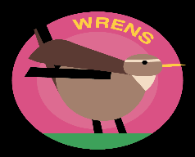 | 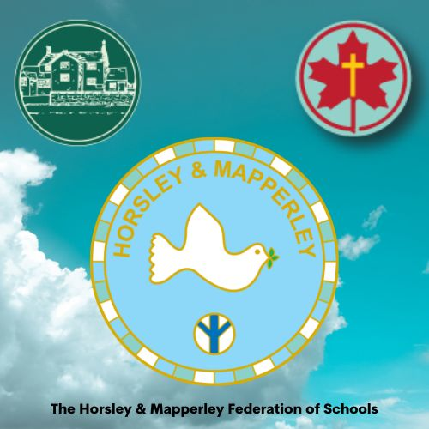
Spring 1 2025
Dear Wrens families,

I hope that you all had the most enjoyable Christmas and enjoyed the break. This term our topic is “Come Fly with me – Arctic Circle.” Come Fly with me – Arctic circle is a thematic unit based on the Arctic Region and surroundings, with a key focus on Geography. We will learn about the location, weather and climate in the Arctic, as well as the wildlife that lives there. The Inuit people and their traditions and customs will also be studied.

Recommended Reading:
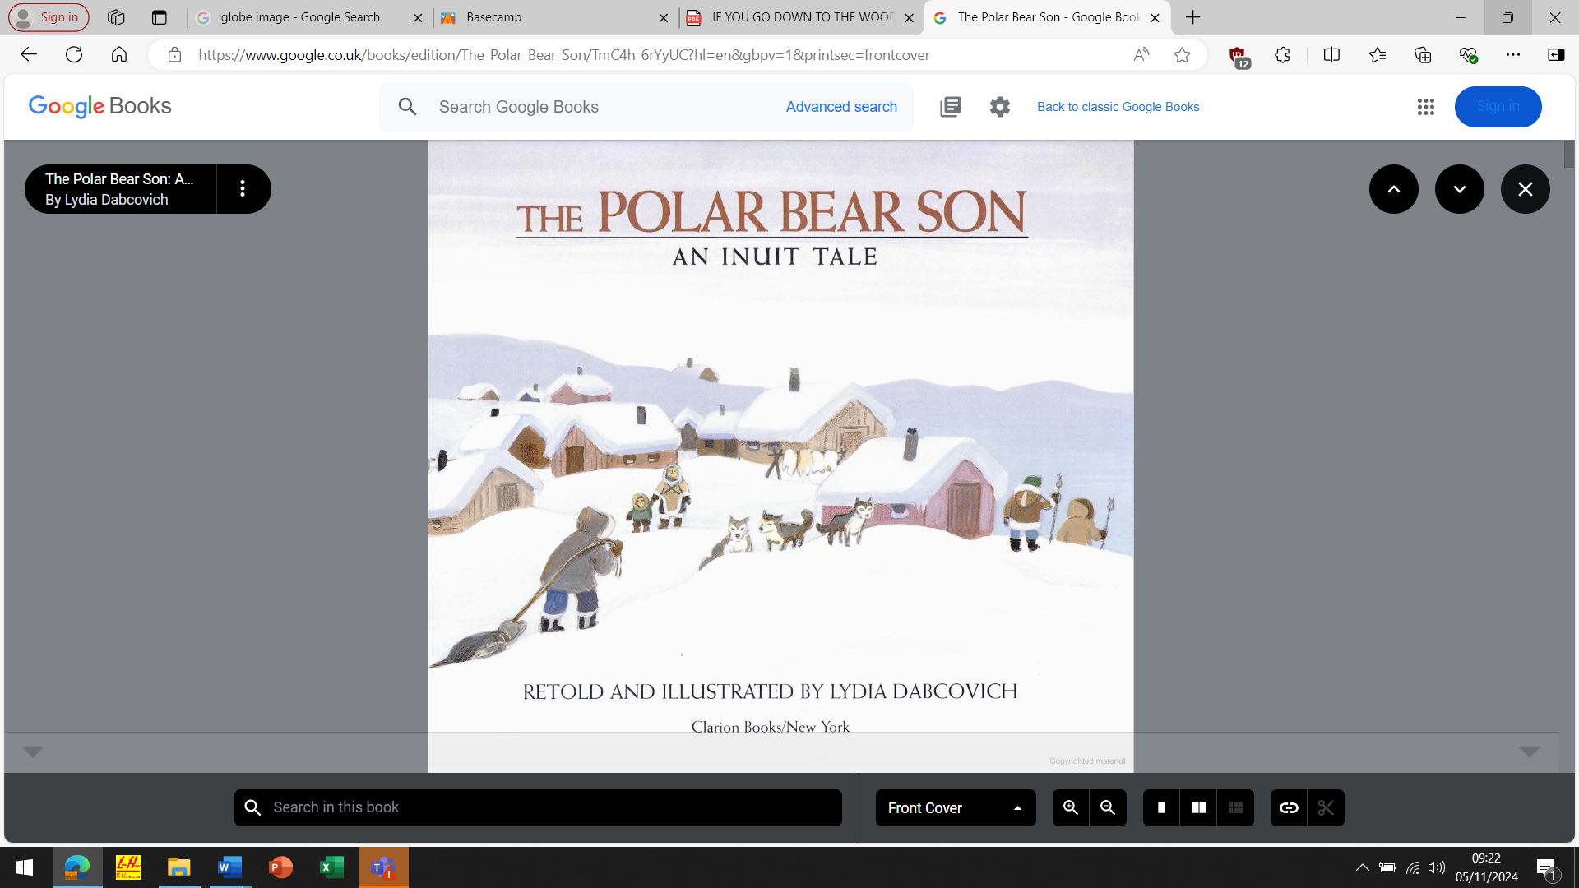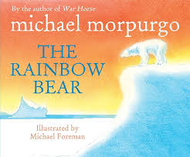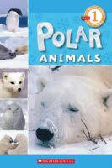

Sticky Knowledge:
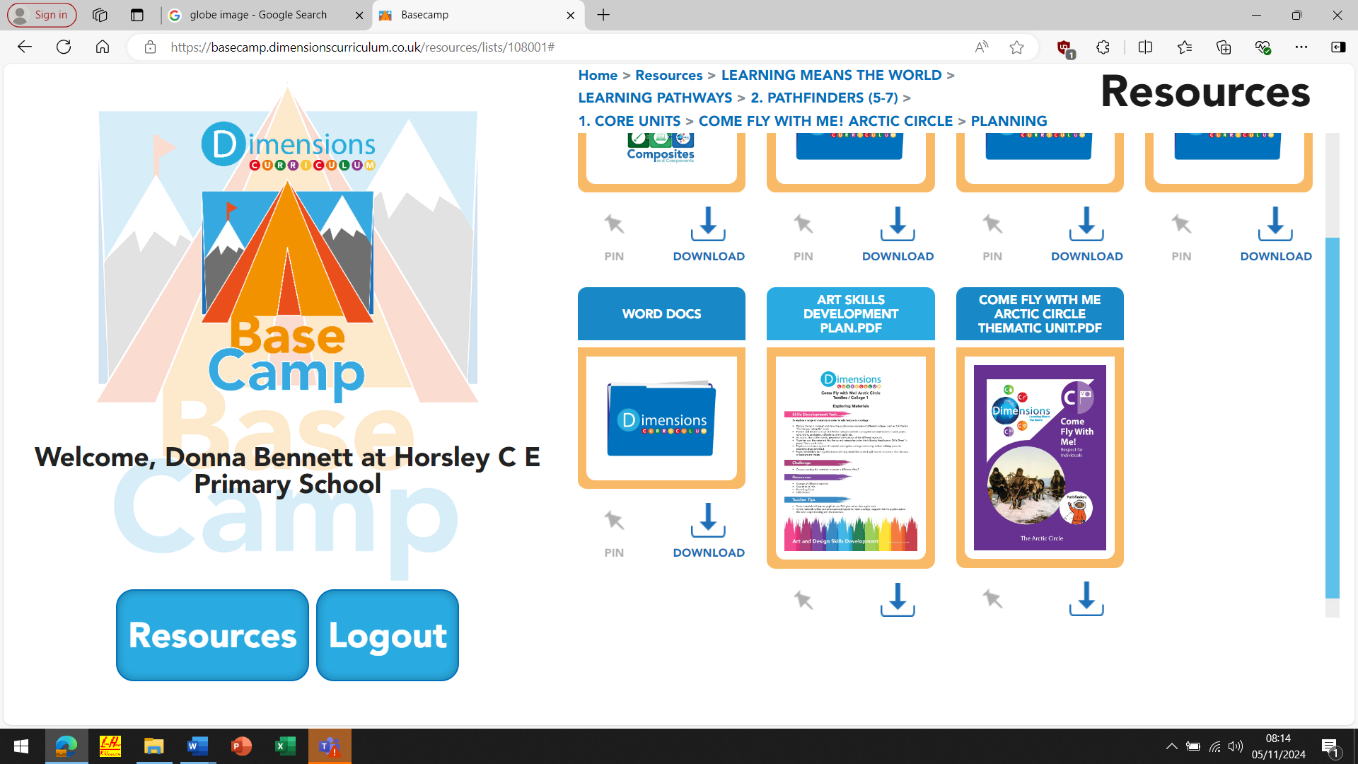

WHERE?
Where is the Arctic Circle?
The Arctic Circle is an imaginary line around the top of the globe. It is the most northern part of the Earth and is made up of the Arctic Ocean and parts of Canada, Russia, Greenland, USA, Norway, Finland, Sweden and Iceland.

WHO?
Who are the Inuit people?
The Inuits are a people group who live in the Arctic region and have found many clever ways to survive there. They wear thick clothes, made from animal fur and used to live in igloos, made from blocks of ice. They now mainly live in houses, but still build igloos to stay in when they go hunting. They use a harpoon to hunt animals and fish in the winter, and gather plants like berries and seaweed in the summer months. There are still hardly any shops in the Arctic Circle—things they really need and other food is brought in by plane or boat.

WHAT?
What is the weather like?
There are nine months of freezing cold weather (temperatures can drop as low as –70°C!) and three months of warmer weather.

WHEN?
When can you see the sun in the Arctic?
In the winter, you might not see the sun for a day, a week or even a couple of months. In the summer, there is the midnight sun, when the sun is visible even at midnight!
HOW?
How do plants and animals survive in the Arctic?
The plants in the Arctic have shallower roots because the soil is so thin, and smaller leaves, so they keep their moisture. Animals camouflage with the habitat and many have a layer of blubber to keep them warm.
How to…

Find the Arctic Circle on a globe.
The very top circle around the top of the globe is the Arctic Circle, and the Arctic is above this line. There are other imaginary lines on the globe. Can you find the imaginary line around the centre of the Earth with your child? Tell them that this is known as the Equator.

Key Vocabulary you should discuss with your child
Aurora Borealis: the Northern Lights—a natural display of coloured lights in the sky.
Blubber: layer of fat
Camouflage: colouring that helps an animal blend in with its surroundings
Climate: weather over a long time
Globe: the Earth or a spherical map of the earth Habitat: a living thing’s natural home Harpoon: a spear attached to a long rope
Hunt: to chase and kill an animal for food Igloo: a shelter made from blocks of snow placed on top of
each other
Imaginary: made-up
Inuit: the people who live in the Arctic
North Pole: the most northern point of the Earth
Concept Flow
- To know what the Arctic Circle is and be able to locate the Arctic Circle on a map
- To understand about the weather and climate in the Arctic Circle
- To find out about animals and plants and how they survive the harsh conditions found in the Arctic
- To learn about the Inuit people group and their customs and traditions
- To learn about the Aurora Borealis (Northern Lights)

Phonics

Reception
-To know all sounds for letters of the alphabet and the diagraphs for Phase 2 and 3 phonics

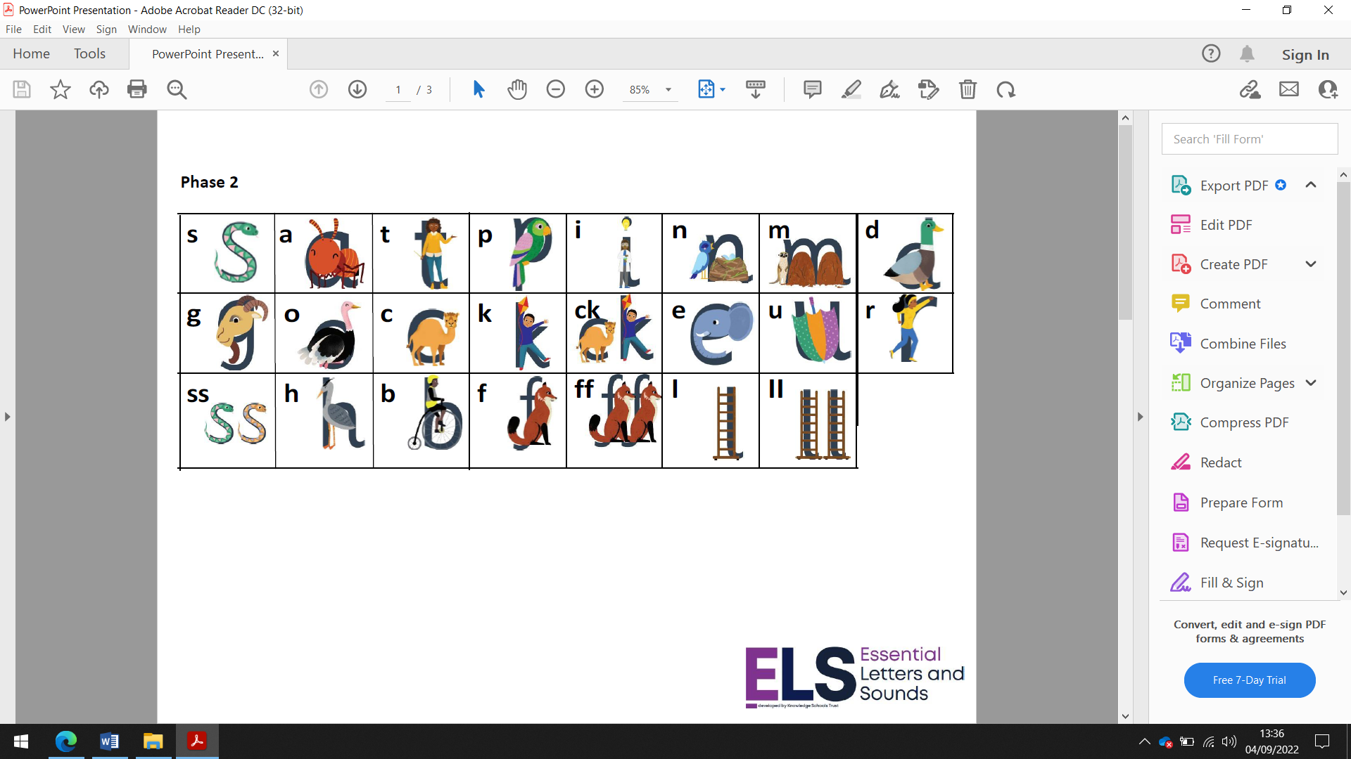

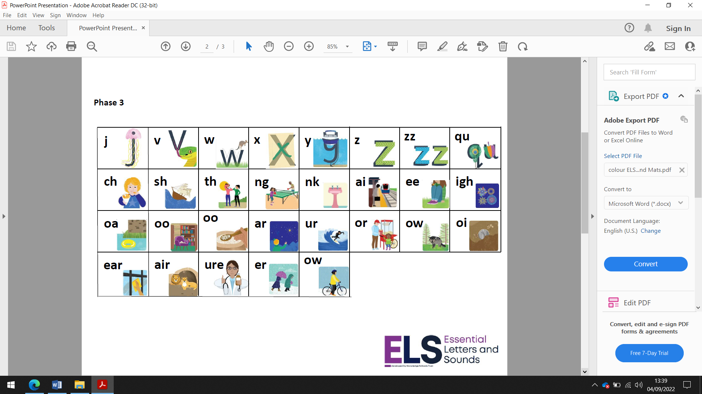
Homework expectations:

Daily reading and High Frequency words
Weekly phonics sheet
To login and complete Mathletics at home each week.

Year One
To know and secure all phonics sounds for phase 2, 3 & 5

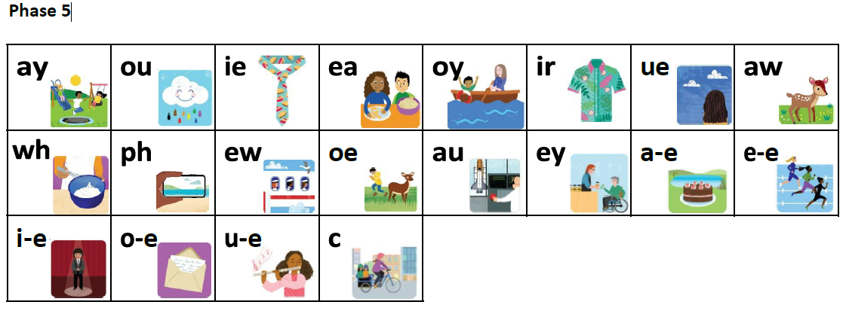

Homework expectations:

Homework – to read 5 times a week at home
Weekly Spellings
Weekly Maths sheet
To login and complete Mathletics at home each week.
Extra if you would like – go to the phonicsplay website and click on the free resources section and play some of the games to read real and non-words using your phonics skills and knowledge.
www.phonicsplay.co.uk

General information:
PE- Thursday and Friday afternoons.

Yours sincerely,
Donna Bennett
Wren’s Teacher.

