  Horsley Church of England Primary School      Mr Richard J Cripps- Headteacher    info@mapperleycont.derbyshire.sch.uk  (0115) 9325386 Mapperley  (01332) 880782 Horsley  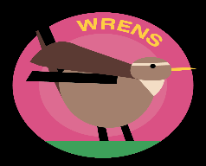 | 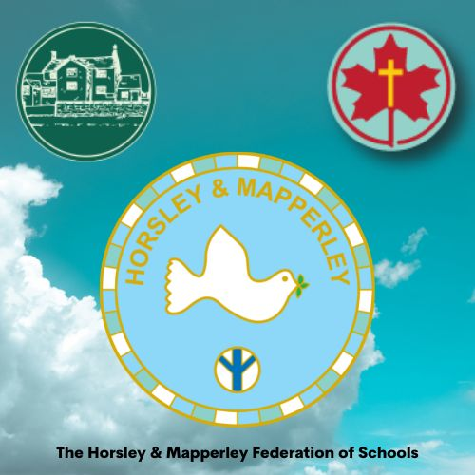
Autumn 2 2024
Dear Wrens families,

This term will be a busy one as we lead up to Christmas. The children will be doing lots of practising for their ‘Baarmy Bethlehem’ performance on 18th December.

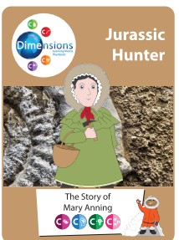
Our topic at the start of this term is called ‘Jurassic Hunter’. This is a history-based theme, with a focus on the four competencies of courage, commitment, creativity and community, integrating the subjects of art, science and geography. The story of Mary Anning, the world’s most famous female palaeontologist, is both challenging and inspirational. We will learn about different types of dinosaurs, big ones and small ones and also learn about fossils and where they come from. Hopefully we will have some dinosaur experts amongst us!
Our sticky knowledge will be:
- Where did Mary Anning live?
- Who was Mary Anning?
- What were some of the fossils that she discovered?

Our second topic for the term is called “Ticket to Ride.” It is all about Transport and how to get around. During this unit we will be learning in different ways. We will be learning about as many different forms of transport as possible and ensuring that we understand what they all are and how they can be used. We will look at the local area and identify places and buildings within it as well as looking at places further afield and discussing where we could go on holiday and how we could travel there.
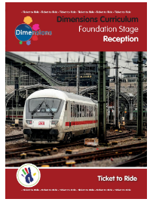
Recommended Reading…
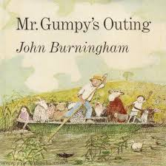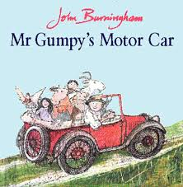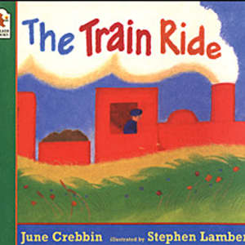
It is good to read books over and over again. It helps children learn the words which helps develop vocabulary, amongst other skills.
Encourage your child to join in when sharing books and talk about what you have read. Discuss unusual words and teach your child to ask what something means if they don’t know.

Our Sticky Knowledge will include:

Understanding the World
- explore the natural world around them
- know that processes and changes occur
- explain some similarities and differences between life in this country and life in other countries
- explore the world around them, making observations and drawing pictures
- know that saying what you see is an important aspect of science
- To know some similarities and differences between things in the past and now

Expressive Arts and Design
- safely use and explore a variety of materials, tools and techniques
- share their creations, explaining the process they have used
- identify a range of colours and simple art techniques

Communication and Language
- listen attentively and respond to what they hear with relevant questions, comments and actions
- make comments about what they have heard and ask questions to clarify understanding
- express their ideas and feelings about their experiences, using full sentences
- participate in small group, class and one-to-one discussions, using recently introduced vocabulary

Key Vocabulary
Tickets Money Ticket Collector Conductor
Queue e-ticket Car Bus Map
Train Travel Fast Slow Motorbike
Ferry Boat Aeroplane Pilot Hot Air Balloon
Phonics
Reception
-To know all sounds for letters of the alphabet and the diagraphs for Phase 2 phonics

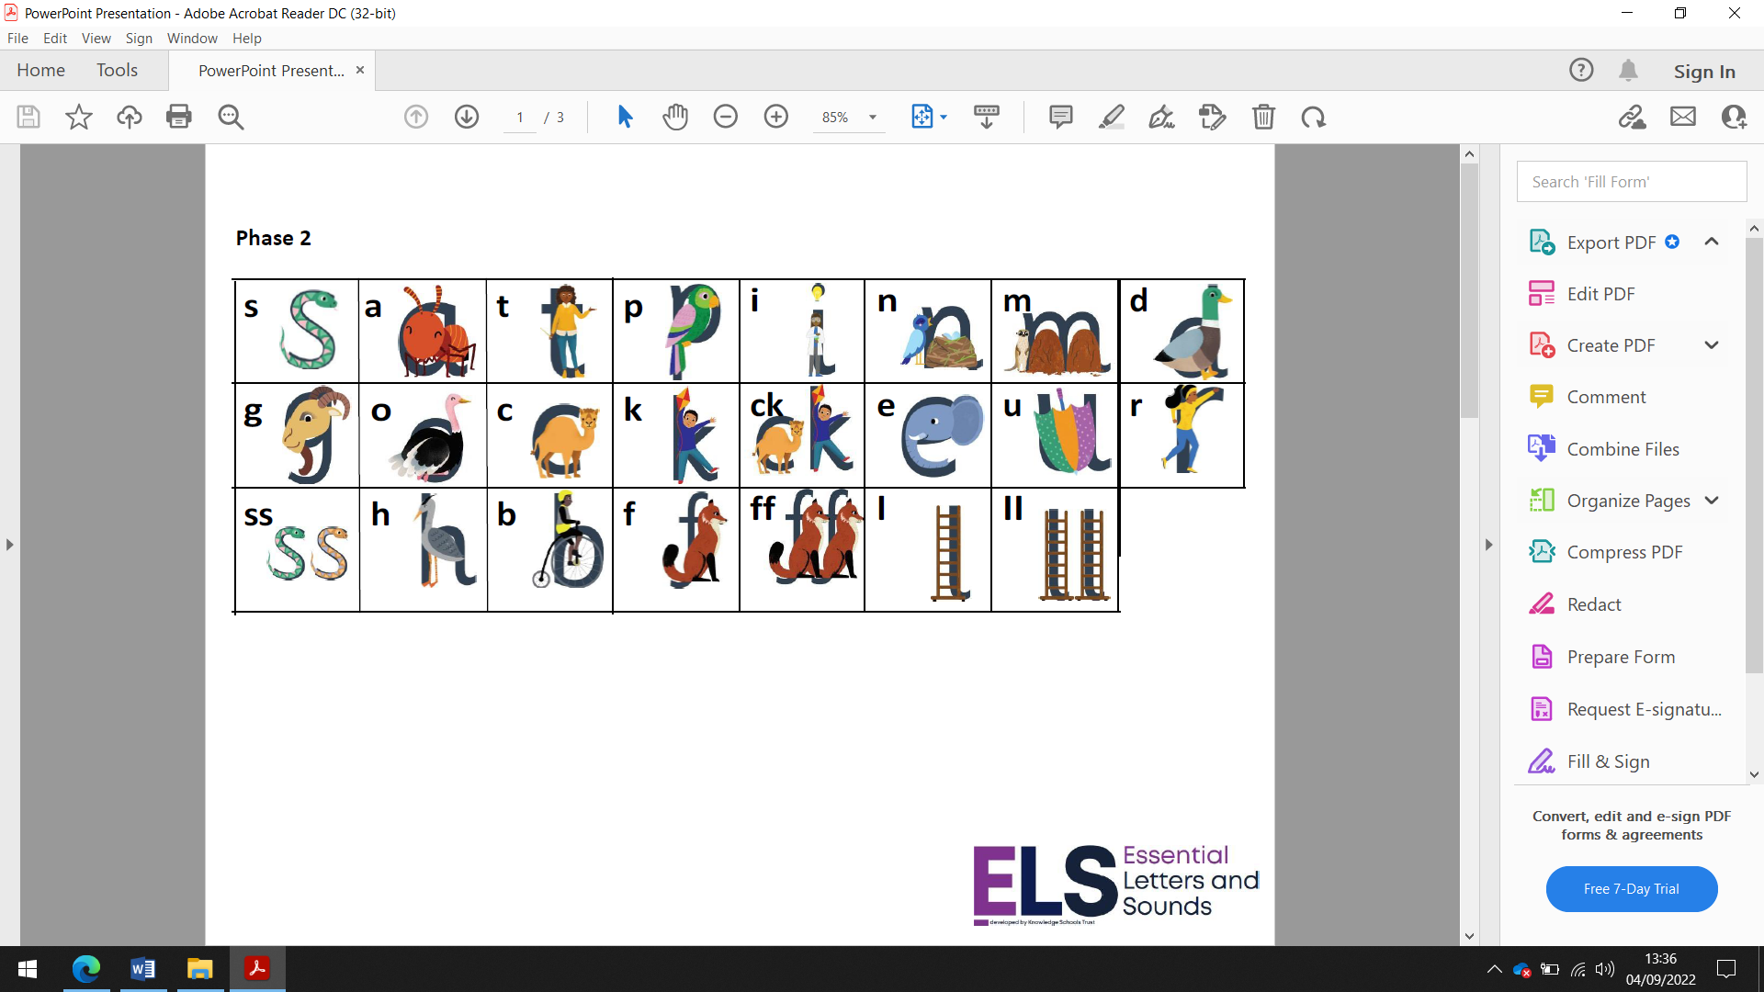

Homework expectations:

Daily reading and High Frequency words
Weekly phonics sheet
To login and complete Mathletics at home each week.

Year One
To know and secure all phonics sounds for phase 2, 3 & 5

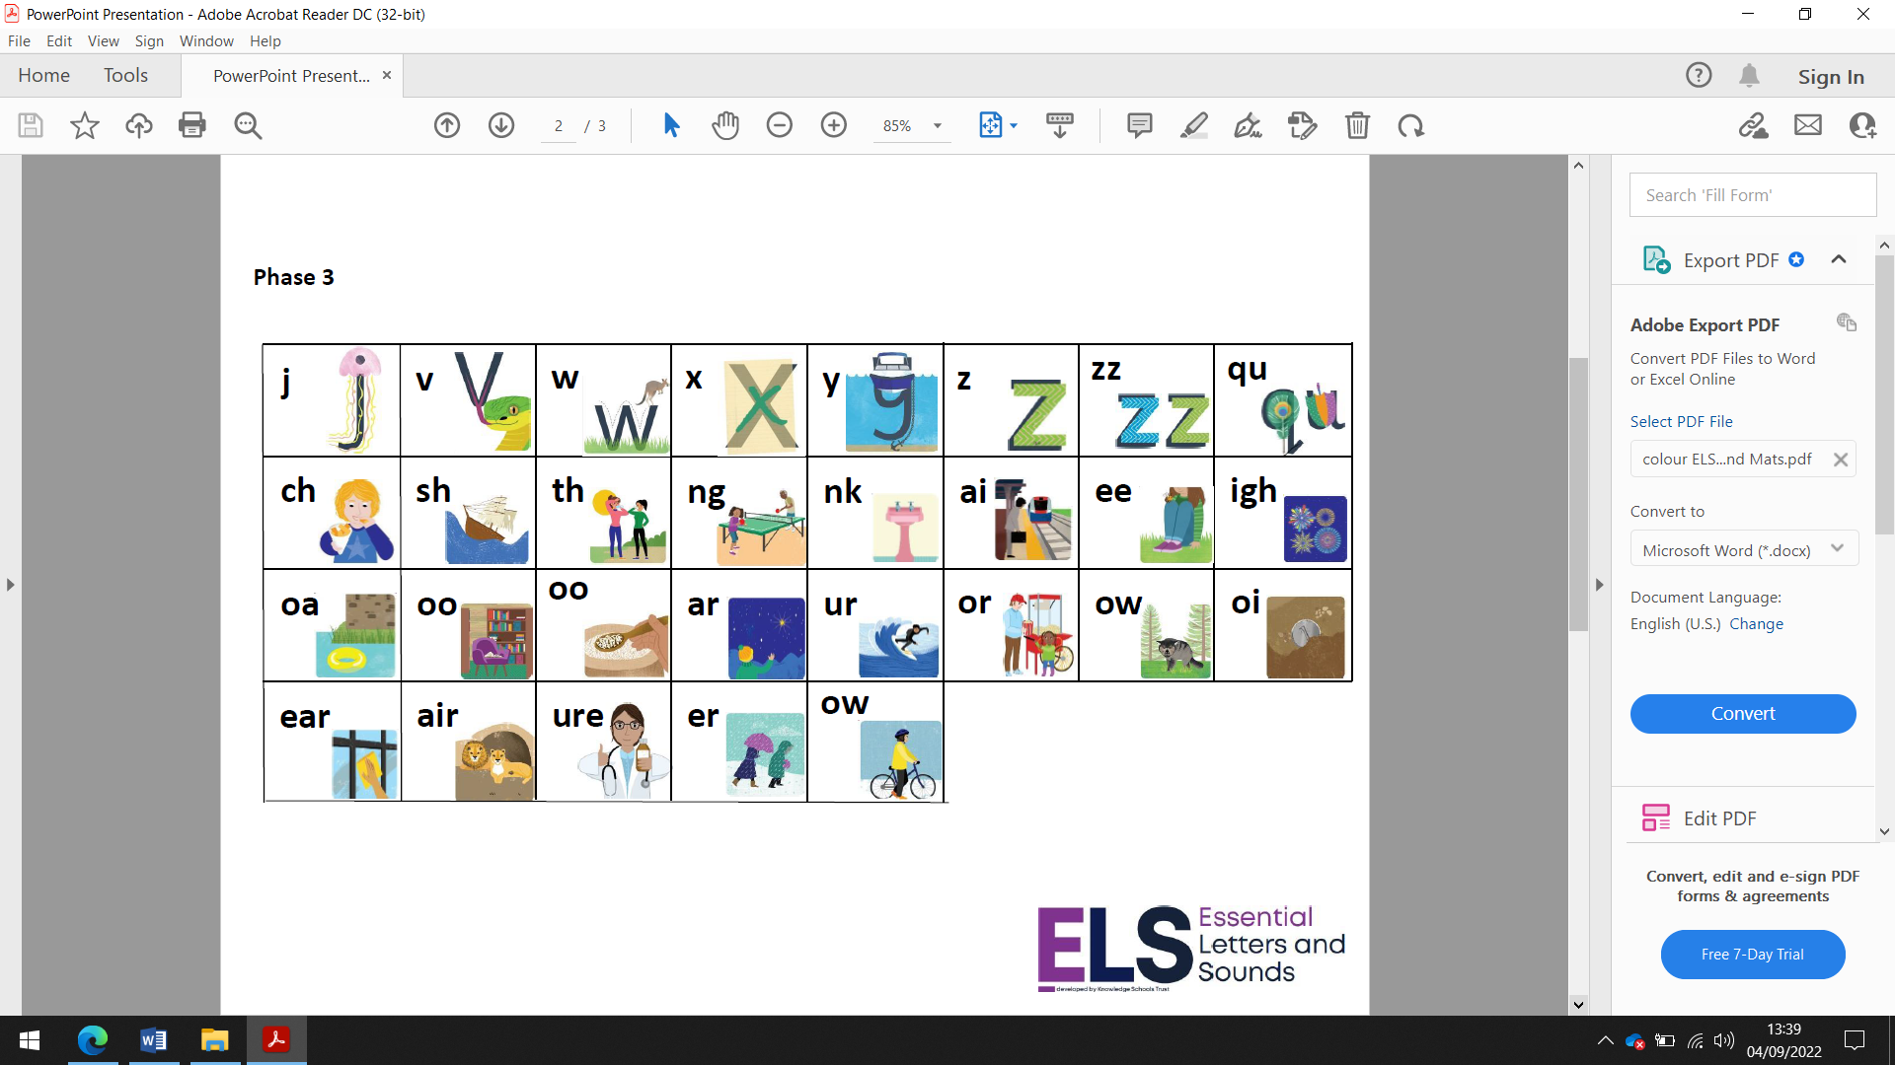

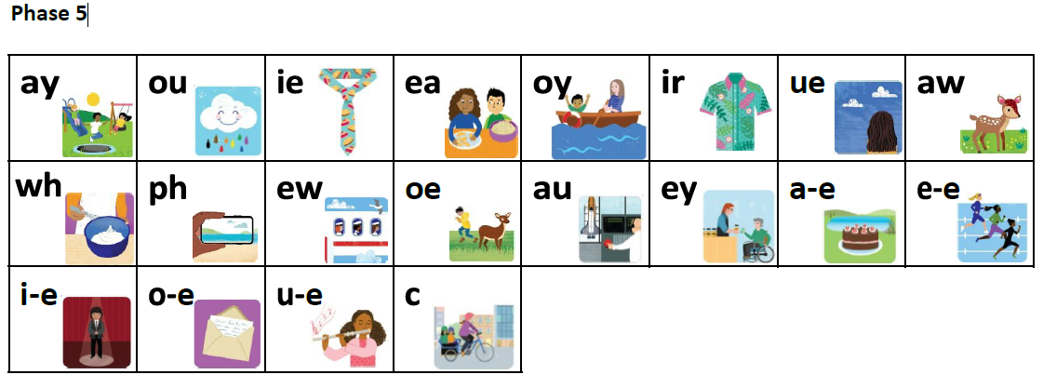
Homework expectations:

Homework – to read at least 5 times a week at home
Weekly Spellings
Weekly Maths sheet
To login and complete Mathletics at home each week.
Extra if you would like – go to the phonicsplay website and click on the free resources section and play some of the games to read real and non-words using your phonics skills and knowledge.
www.phonicsplay.co.uk

General information:
PE- Thursday and Friday afternoons.

Yours sincerely,
Donna Bennett
Wren’s Teacher.

