Class One - Wrens – Autumn Term 1/2, 2024

Reception
Topic – Jurassic Park

Maths -To recognise numbers up to10

Phonics -To know all sounds for letters of the alphabet and the diagraphs for Phase 2 phonics

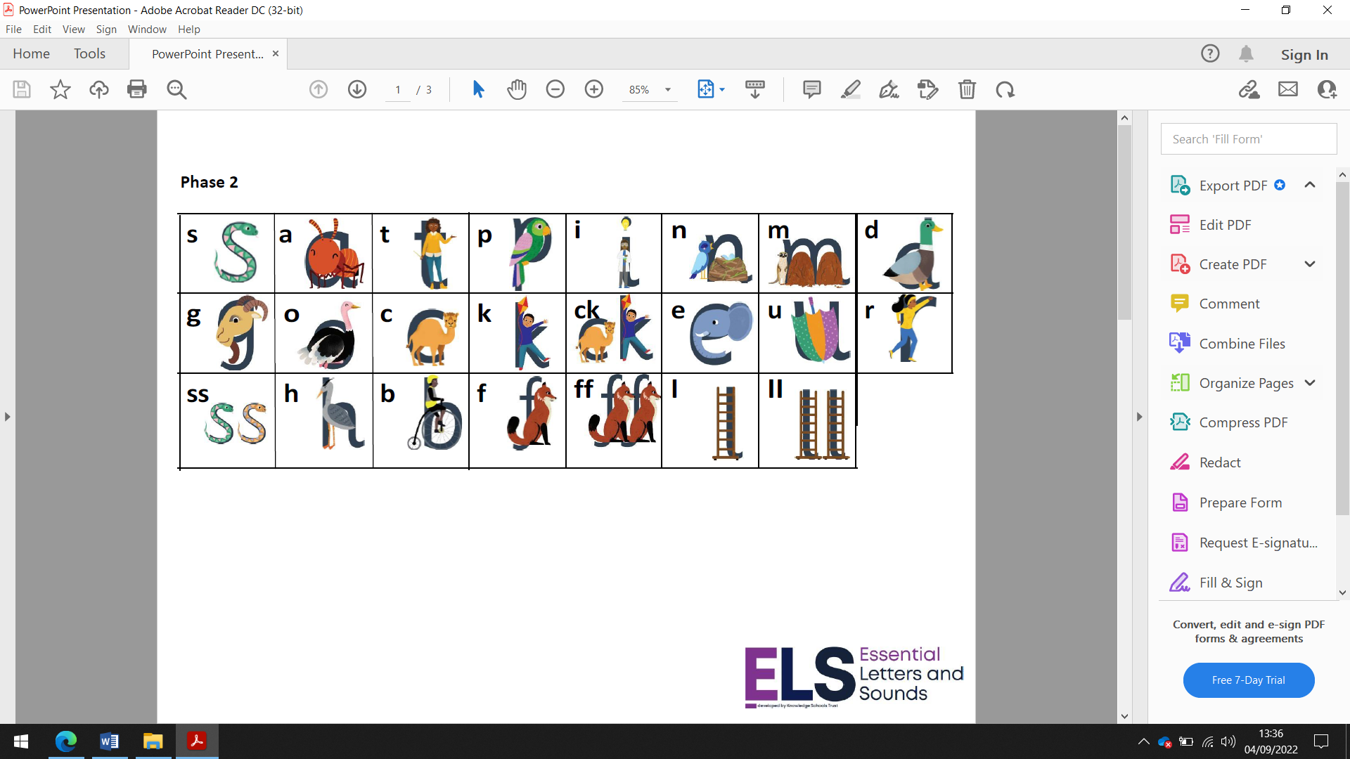
Homework
Daily reading and High Frequency words
Weekly phonics sheet

Year One
Topic – Jurassic Park
Phonics -To know and secure all phonics sounds for phase 2 & 3

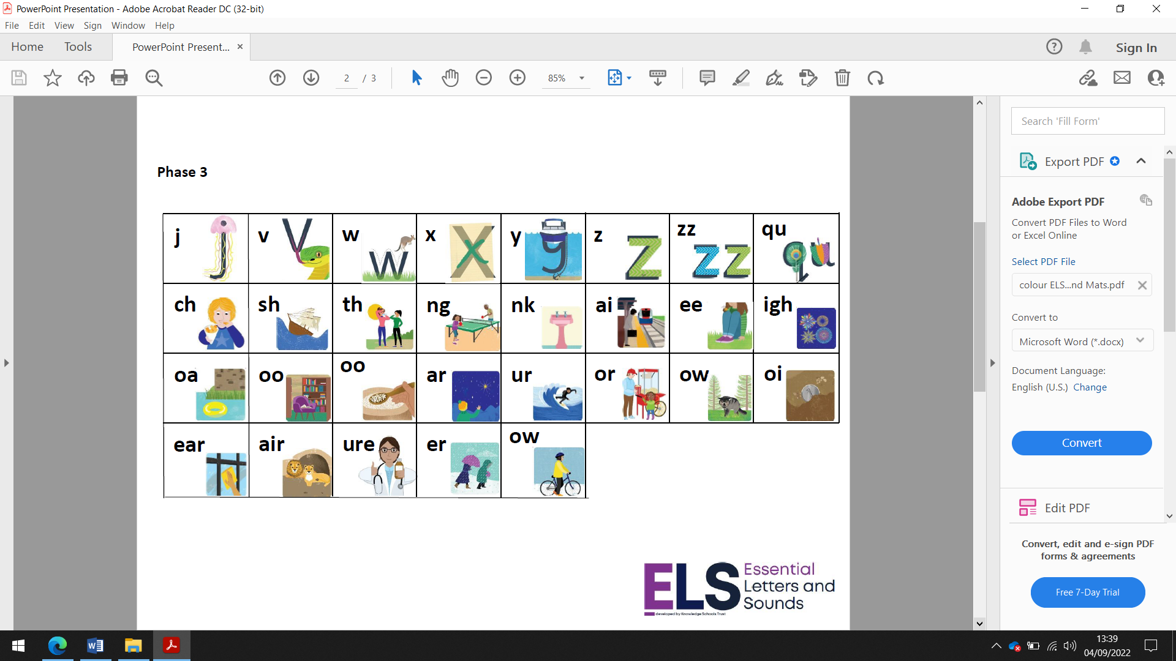

Homework – to read at least 5 times a week
Weekly Spelling
Weekly Maths sheet
To login and complete Mathletics at home each week.
Extra if you would like – go to the phonicsplay website and click on the free resources section and play some of the games to read real and non-words using your phonics skills and knowledge.
www.phonicsplay.co.uk

