For Reception
-To recognise numbers up to 10 and find amounts for each numeral

-To know all sounds for letters of the alphabet and the diagraphs for Phase 2 phonics
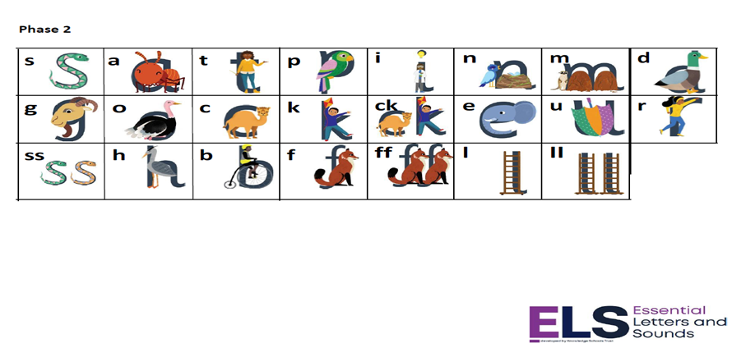

Homework
Daily reading and High Frequency words
Weekly phonics sheet
To login and complete Mathletics at home each week.

For Y1
To know and secure all phonics sounds for phase 2, 3 & 5

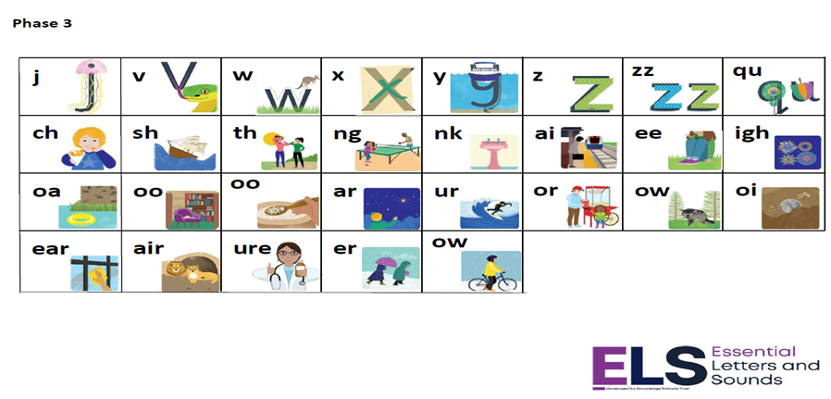

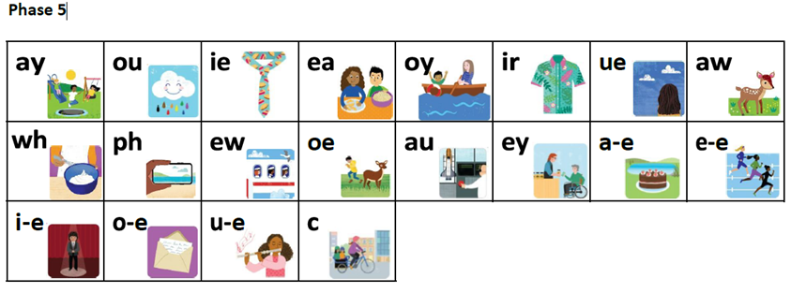

Homework – to read 5 times a week at home
Weekly Spellings
Weekly Maths sheet
To login and complete Mathletics at home each week.
Extra if you would like – go to the phonicsplay website and click on the free resources section and play some of the games to read real and non-words using your phonics skills and knowledge.
www.phonicsplay.co.uk

