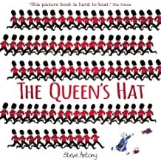
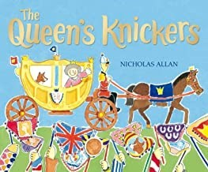
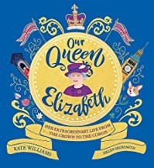
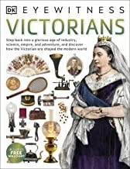
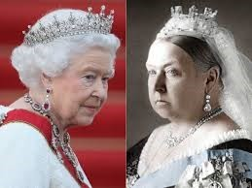
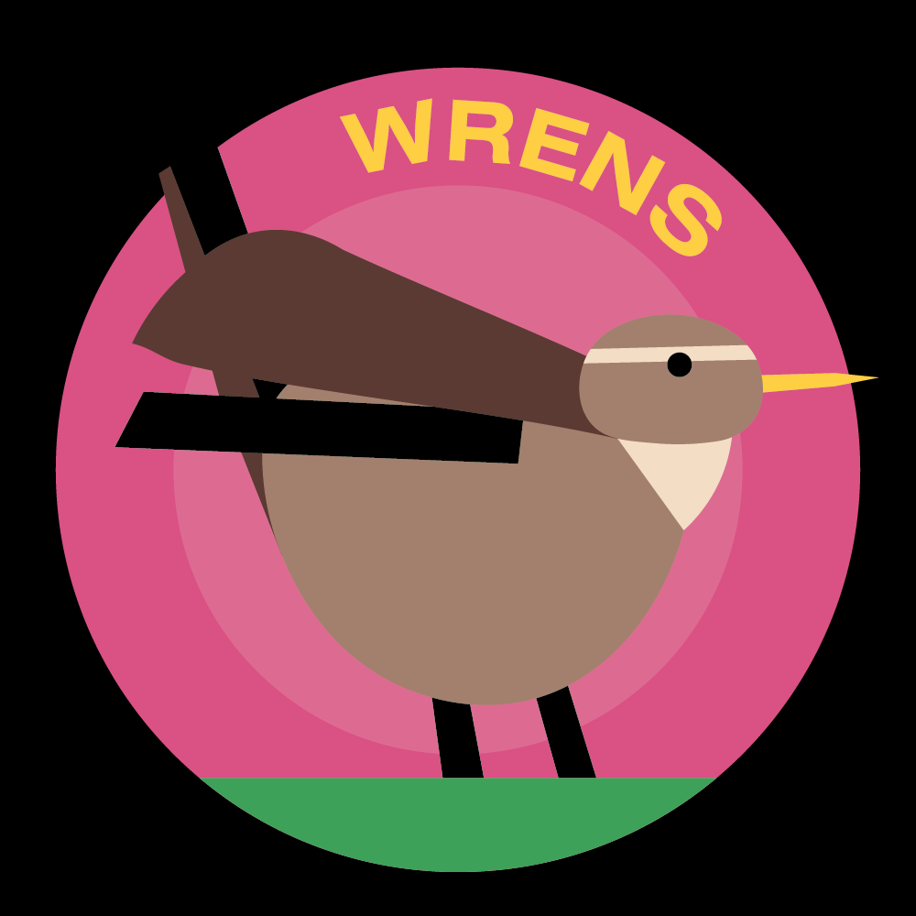 Horsley C of E Primary School
Theme Overview
“Royal Patrons” is a unit with a history focus, comparing the lives of Queen Victoria and Queen Elizabeth II. Elizabeth is a direct descendant of Queen Victoria, her great-great-grandmother, and both are recognised sources of inspiration whose legacies will live on.
HOW?
How have both queens shown commitment?
Victoria continued her duties right to the end of her life. There were two wards whilst Victoria was queen and, even though in the last one she was old and had been queen for sixty years, Queen Victoria gave out medals and visited troops in hospitals.
Queen Elizabeth’s commitment to her duty means that she works every sin- gle day, even though she is now in her nineties! She is the patron of more than six hundred charities and organisations, including Barnardo’s and Cancer Research, and is the longest serving monarch in history.

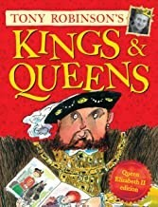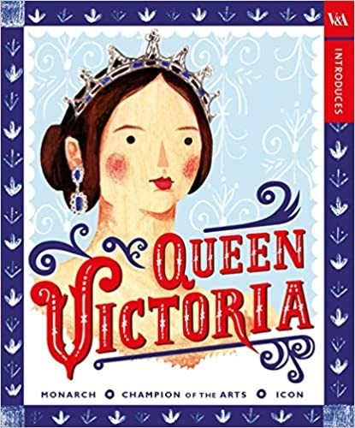
Recommended Reading…

What we should know…
WHEN?
When did they reign?
Victoria became queen in 1837 and died in 1901. She reigned for 63 years. Elizabeth became queen in 1952. She is the longest reigning queen in history!
WHY?
Why did Victoria and Elizabeth become queens?
Victoria became queen after her uncle, the king died. He had no children and Victoria was his nearest relative. She was just 18.
Elizabeth became queen when her father, King George VI Died. She was 25.
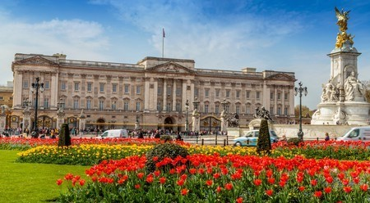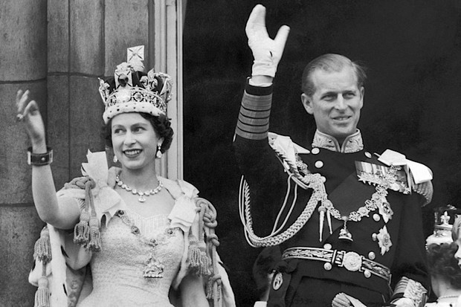
WHAT?
What did Victoria do in her lifetime that showed courage? Victoria was only 18 when she be- came Queen, in an era when wom- en were completely controlled by men! Seven times in her life, people tried to kill Victoria. She became very popular because she was so brave about these attacks.

Who?  Who was awarded the Victoria Cross medal?  This medal was introduced by Queen Victoria in 1856, to hon- our acts of great bravery during the Crimean Wart. It is the most important medal—the highest honour for bravery in war— and can be awarded to any soldier. Only 13 people have been awarded the Victoria Cross since the end of World War 2. | Skills  Use different sources of information to find out about the past  Find out about the lives of significant people and events from the past and present  Using episodes from stories about the past, identify the difference between past and present  Place events in chronological order  Use common words and phrases related to the pass-  ing of time  Make a personal link to the past by exploring arte- facts and images  Explore places and investigate artefacts  Recognise why people did things and why events hap- pened  Identify differences between past and present and show how ways of life at different times were different to their own  Identify different ways in which the past is represent- ed  Observe and handle a range of sources of information  to find out about the past  Place events and objects in chronological order Use a wide vocabulary of everyday historical terms
Key Vocabulary you should discuss with your child
Carriage: a vehicle with wheels for carrying people

Century: one hundred years

Duty: responsibility

Era: time

Monarch: king or queen

Patron: special supporter/ figurehead

Portrait: a picture of a person, usually showing their face

Reign: the rule of a king or queen

Victorian: the time when Victoria was queen

Concept Flow
- To know about changes in their own lives, their families lives and others around them
- To know some differences between how people used to live at different times
- To know who Queen Victoria was and who Queen Elizabeth II is
- To understand the contribution both Queens have made to British society
- To understand the way in which the past impacts on the present
- To understand the importance of courage, commitment and community

Please talk to your children about the information on this sheet. The more children discuss their learning the more likely they are to embed the learning to their memory. If you have any questions please don’t hesitate to contact your child’s class teacher.

