Class One - Wrens – Spring 2 2024

Reception
-To recognise numbers up to 10 and find amounts for each numeral
-To subitise up to 5 objects.
-To know number bonds for numbers up to 5.

-To know all sounds for letters of the alphabet and the diagraphs for Phase 2 and Phase 3 phonics

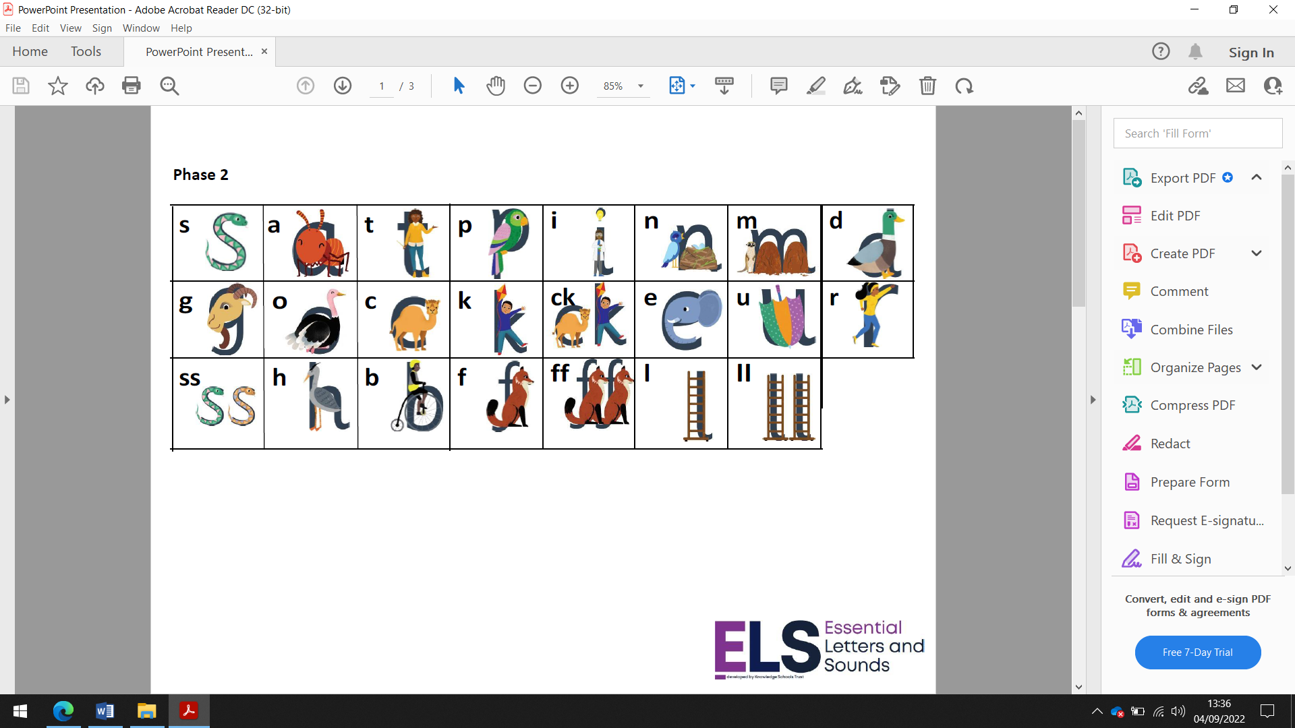

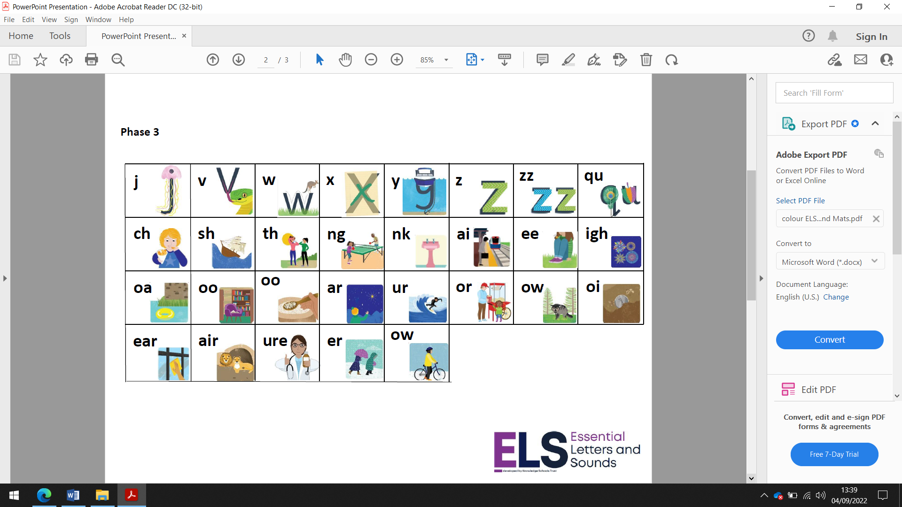
Homework
Daily reading and High Frequency words
Weekly phonics sheet
To login and complete Mathletics at home each week.
If you would like to do extra, to login and do a Purplemash activity of your choice.

Year One
-To recognise numbers to 50
-To add and subtract numbers to 20
-To count in steps of 2, 5, 10

To know and secure all phonics sounds for phase 3 & 5

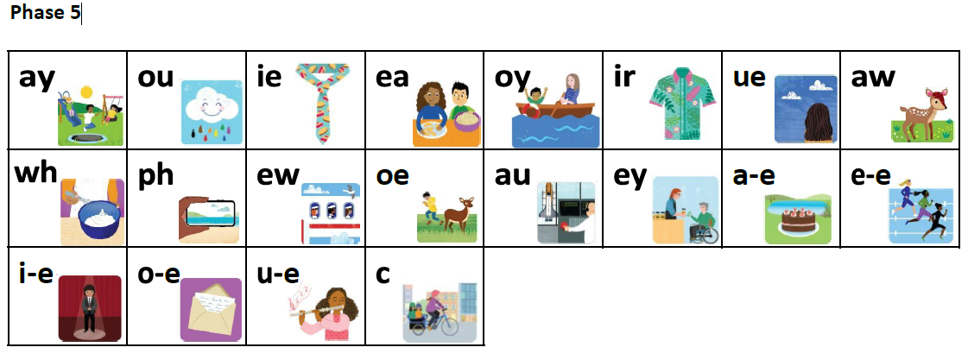

Homework – to read 5 times a week at home
Weekly Spellings
Weekly Maths sheet
To login and complete Mathletics at home each week.
Extra if you would like – go to the phonicsplay website and click on the free resources section and play some of the games to read real and non-words using your phonics skills and knowledge.
www.phonicsplay.co.uk

