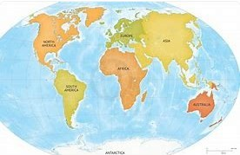
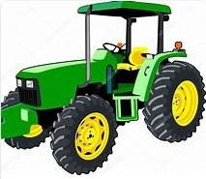
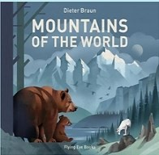
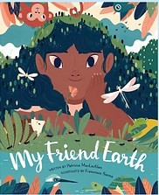
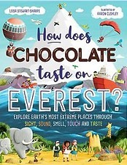
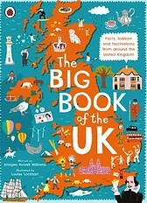
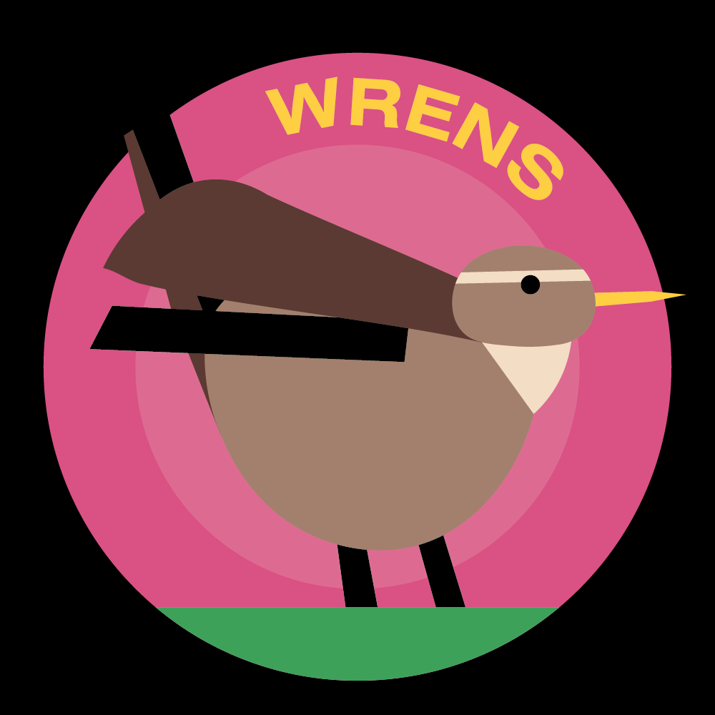 Horsley C of E Primary School
Theme Overview
“Never Eat Shredded Wheat” is a thematic unit based around where food comes from, with a key focus on geography. It begins by looking at compass directions and locational language, before moving on to learning about continents and oceans. Physical and human geographical features are explored, and the UK is then ex amined more closely. The learning then moves on to where foods come from around the world.

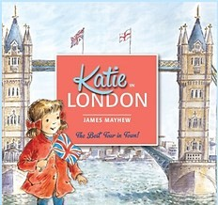
Recommended Reading…

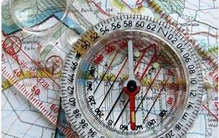
What we should know…
How?
How can we find countries in the world?
- We can look at maps and globes to find out where countries are.
- Seas are coloured blue and countries are usually green, brown or yellow on maps
What?
What are the four points?
  - North, south, east and west
What are the four countries in the UK?
  - The countries of the UK are England, Northern Ireland, Scot- land and Wales.
What are the names of the continents and oceans?
  - There are seven continents in the world: Asia, Africa, North America, South America, Antarctica, Europe, Australasia, and five oceans: Arctic, Atlantic, Indian, Pacific, Southern

Where? | Why?  Why are aerial views useful?  - You can see a large are of the ground in a lot of detail.  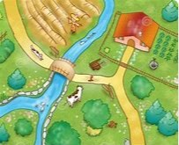 | Why?
Where are the capital cities of the UK?  - London is in the South East of England  - Edinburgh is in the East of Scot- land  - Belfast is in the East of Northern Ireland  - Cardiff is in the South East of  Wales |  | Who helps to bring us food?  - Farmers, fisherman and fruit pickers grow, catch and pick food for us to eat. People transport food to shops and shopkeepers and market  stallholders sell the food to us.

How to...  ….use a compass  A compass always points north. Place the compass flat on your palm and find out where you are facing by seeing where the arrow points to. Practise walking north, east, south and west. |  | Key Vocabulary you should discuss with your child  Directions: the path along which something moves, lies or points  Flag: a piece of cloth with a special design or colour that is used as a symbol of a nation  Human Features: places and things that been built or made by people  Itinerary: a planned route or journey Landmark: Something that is easy to see and can be used to find your way to a place near it Locality: the areas nearby  Location: a place or a position  Map: an image of an area  Mountain: raised land, higher than a hill Physical features: a natural feature Vegetation: plants, trees and bushes Village: a little town
Key Vocabulary you should discuss with your child Aerial View: a picture of something from above
Beach: usually made of sand or pebbles and slopes to meet the sea
Capital City: large place where the government of a country functions
Compass: a tool for finding direction
Continent: a major area of land, made up of different countries

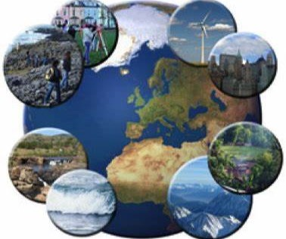
Concept Flow
- To know and use simple compass directions (North, South, East and West) and locational language
(e.g. near and far) to describe the location of features and routes on a map.
- To name, locate and identify characteristics of the four countries and capital cities of the United Kingdom and its surrounding seas.
- To name and locate the world’s seven continents and five oceans.
- To know, understand and apply basic geographical vocabulary to refer to key physical features, including valley and coast.
- To know, understand and apply basic geographical vocabulary to refer to key human features, including city, town, village, factory, farm.
- To look at aerial photographs and plan perspectives to recognise landmarks and basic physical features.
- To learn where in the world food comes from.

Please talk to your children about the information on this sheet. The more children discuss their learning the more likely they are to embed the learning to their memory. If you have any questions please don’t hesitate to contact your child’s class teacher.

