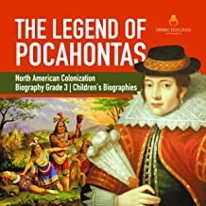
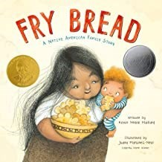
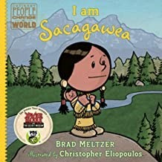
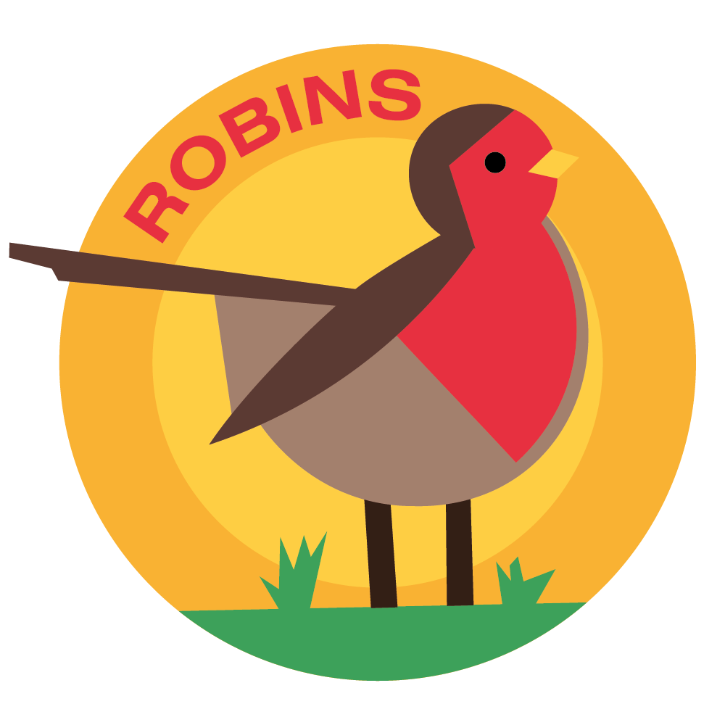Horsley C of E Primary School
Theme Overview
Powhatan People is a history-based theme, with a focus on the four competencies of courage, commitment, creativity and community, integrating the subjects of dance, drama, English, PSHE, RE and geography. This is the inspiring story of Pocahontas, who became famous for breaking down cross-cultural barriers between her tribe and English colonialists.

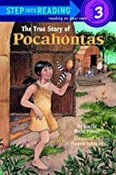
Recommended Reading…

What we should know…
WHERE?
Where did Pocahontas live?
Pocahontas was born in Virginia, USA in the year 1596. In 1616, she moved to England with her new husband and child. Pocahontas was one of the first Native Americans to go to England.
WHO?
Who was Pocahontas?
Pocahontas was a Native American Indian, the daughter of Chief Powhatan, making her princess of the Powhatan Tribe. She became a great leader and mediator when English colonialists invaded her land and helped to free some of her tribe from their captivity. Through her leadership, friendship and negotiation skills, she enabled a time of peace between the two sides.
Upon meeting her husband, John Rolfe (who was English), she converted to Christianity, changing her name to
Rebecca Rolfe. Once Rebecca had arrived in England, she helped to grow the understanding that all people, no matter their culture, deserve respect and kindness.

WHAT?
What happened to Pocahontas before she met John Rolfe?
In 1960, she married an Indian Warrior named Kocoum, and, shortly after, gave birth to their son, Little Kocuom.
However, by 1613, the relationship between the English colonialists and Native Americans got worse and even more fighting broke out. As a result, Pocahontas was captured because she was the daughter of the chief!
Sadly, after she was captured by the colonialists, they also killed her husband Kocuom, but her son was rescued and raised by a neighbouring tribe.
However, some good came out of her captivity because, during this time, Pocahontas learned the English language, religion and customs.

Key Vocabulary you should discuss with your child
Captured: To be taken by force

Chronological: Recording events in the order in which they occurred
Conflict: A serious disagreement or argument between two or more sides
Cross-cultural: To relate to different cultures and comparisons between them
Culture: The ideas, customs, and social behaviour of a particular people or society

Forage: To search for food

Masque: A form of popular entertainment in the 1600s with masked drama and dancing Native: A person born in a specified place or associated with a place by birth
Negotiate: To try and reach an agreement or compromise by discussion
Powhatan: The name of the tribe that Pocahontas belonged to

Responsible: Having control or care for someone or something as part of one’s job or role

Tribe: A large number of people, consisting of families or communities linked by the same values and cul ture, typically having a recognised leader

History
• To understand the contribution Pocahontas made to cross-cultural relationships
• To understand what makes Pocahontas an inspirational historical figure
• To understand the importance of community, courage and commitment

English (Reading and writing) – How Coyote Brought Fire to Earth.
- Write a vivid description and innovate a story.
Spelling Phase 6 Phonics (adding -est,-mb saying ‘m’, -a and al saying ‘or’, adding -ing and -ed)
The Year 2 Statutory spelling are also covered and assessed regularly.
Grammar: verbs, singular and plural, adverbs wth -ly, commas in a list, changing adjectives to adverbs
Maths: Money, Length & height, Mass, capacity & temp.
Art: Design and make totem poles.
Computing: On-line safety & Presenting Ideas

RE: What do Christians believe God is like?
PSHE: Money Matters
PE: Invasion Games and Swimming
Homework
Read 5 x a week at home. Learn spellings weekly. Use Mathletics and TT Rock Stars plus one other piece of homework.

