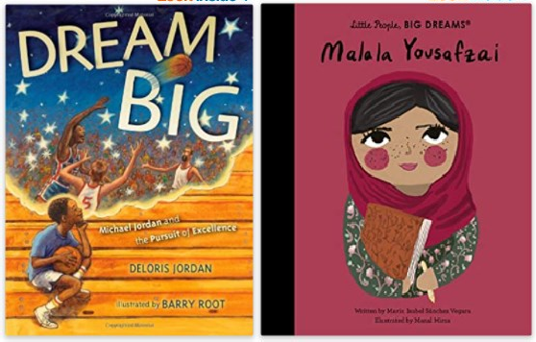
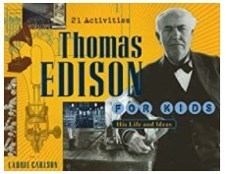
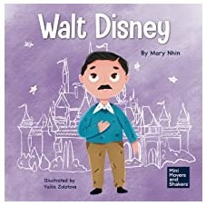
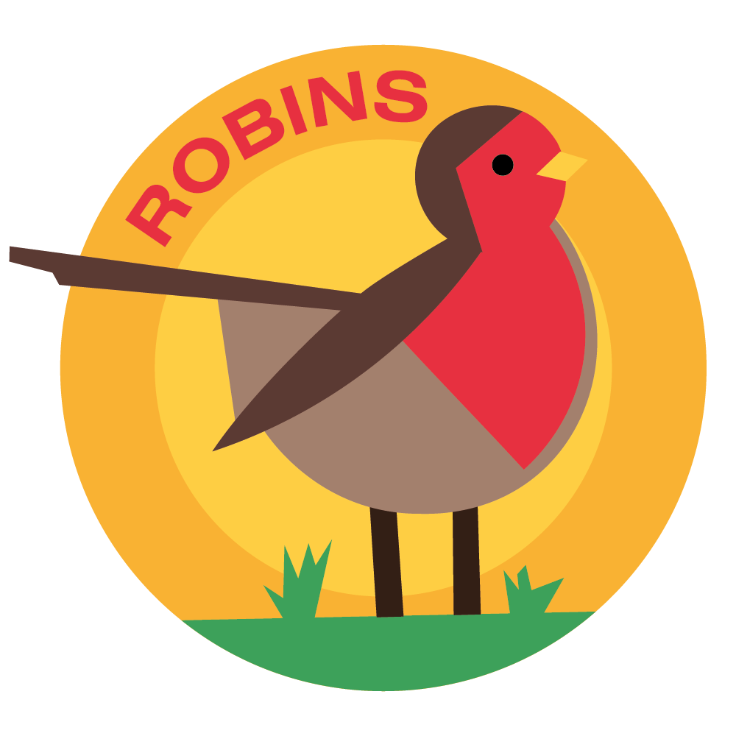 Horsley C of E Primary School
Theme Overview
“Zero to Hero” is a thematic unit about heroes and heroines, both past and present, who have overcome major challenges in life and become inspirational figures. There is a key subject focus on history. You will learn about different people, of different ages, from different cultural backgrounds who all have one thing in common - courage and determination.


Recommended Reading…

What we should know…
WHO?
Malala Yousafzai • Famous for campaigning for girls’ education
Thomas Edison • Invented the light bulb Michael Jordan • Famous basketball player Walt Disney • Created some of the first cartoons Mother Teresa • Helped poor people in India

WHY?
Why is Malala Yousafzai a hero? • Malala is incredibly brave. She was shot by the Taliban because she spoke out about how important it is for girls to be allowed to go to school, so they can achieve their dreams.
Why is Thomas Edison a hero? • He tried and failed over 1,000 times before he got it right! He never gave up and, eventually, invented the working light bulb.
English
We will be reading and working on‘Eliot Jones, Midnight Superhero’, ‘Supertato’ and
‘I am Rosa Parks’
Maths

Multiplication and division

Money

RE
What makes a place sacred?

PSHE
Bullying Matters

PE - There will be no PE on Mondays due to Swimming on a Thursday.
Friday PE will be Invasion Games.
Extra - There will be a Superhero dress up day on a date to be confirmed at the end of term.

Key Vocabulary you should discuss with your child
Brave: showing courage
Calcutta: a very poor city in India
Create: Make or design something that has not been made before
Failure: when things go wrong
Hardship: severe difficulties
Inventor: somebody who invents things
Nun: a woman who has given herself to God and lives with other nuns. They keep promises to not be rich, not get married and do what God says
Perseverance: keeping going, keeping trying Rejection: when people say ‘no’ to you Respect: treating somebody or something well
Saint: a very kind and special person – a title given by the Roman Catholic Church Slums: an overcrowded, poor, dirty area where the people who live there are very poor Taliban: very extreme Muslim fighters

- Homework Expectations
- Regular reading – 5 times a week. Asking them question to check their understanding.
- Math -Mathletics, and TT Rock Stars
- Writing – grammar homework and other writing tasks set around topic

Please talk to your children about the information on this sheet. The more children discuss their learning the more likely they are to embed the learning to their memory. If you have any questions please don’t hesitate to contact your child’s class teacher.

