  Mapperley Church of England Primary School      Mr Richard J Cripps- Headteacher    info@mapperleycont.derbyshire.sch.uk  (0115) 9325386 Mapperley  (01332) 880782 Horsley | 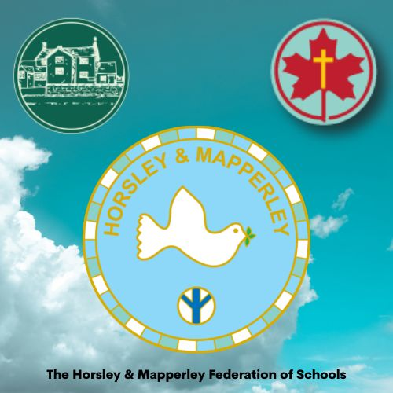  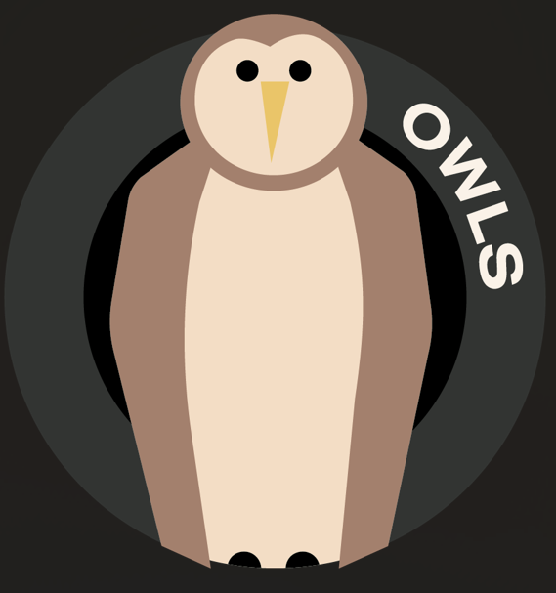  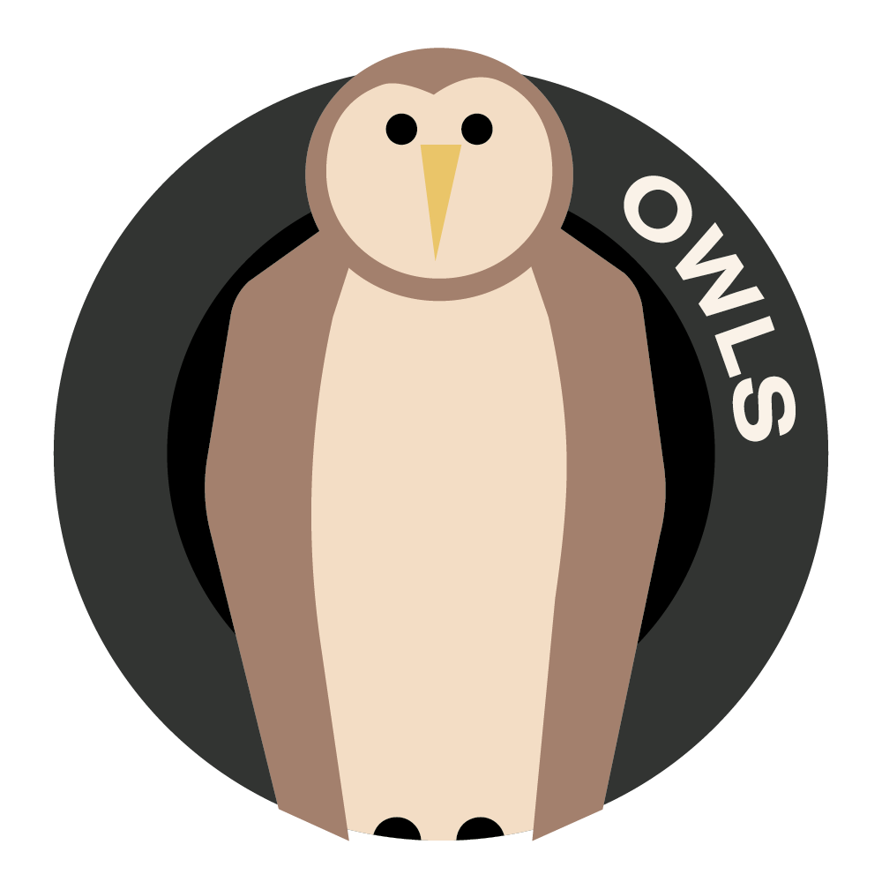
Spring 1 2025
Dear OWLS families,
This term we have a thematic unit based around slavery, called “Cry Freedom”. It looks at the history and origins of slavery around the world, before moving on to learning about some key figures involved in the abolition of slavery. Pupils will also learn about modern-day slavery, including child labour.
In Science we be investigating light, reflections and shadows and also learning about Earth and Space.
In Maths we will are learning about Fractions and preparing Year 4 for their Multiplication Tables test.
In English, our thematic work linked to the topic will include Persuasive Writing, Non-Chronological Report and Haikus. We are also reading and studying the book Holes by Louis Sachar.
In Computing we will be learning about presenting information.
In Music, our Singing lessons with the Cathedral Singing Project continues alongside learning about timbre.
In French we are learning to talk about our hobbies.
In RE, children will be learning about creation and science and discussing whether these are conflicting or complementary theories.
In PSHE, children will be learning about being healthy in a variety of ways.
General information – PE will be on Tuesdays and Fridays.
Homework expectations
- Regular reading – 5 times per week please.
- Weekly CGP Reading Comprehension pages.
- Spelling – as well as learning spelling rules in lessons, we will continue to learn and test the Y3/4 or Y5/6 Spellings. Your child’s words will be in their GREEN spelling book. Tests are done in this book at the end of the week.
- Maths – Mathletics, TT Rockstars
ALSO - Purple Mash offers a range of activities, games and computing skills. It also has a wide range fiction and some non-fiction texts in Serial Mash. Many have online reading comprehension tasks.

Best wishes as we start 2025,
Mrs Bell and Mrs Whiteley

