  Mapperley Church of England Primary School      Mr Richard J Cripps- Headteacher    info@mapperleycont.derbyshire.sch.uk  (0115) 9325386 Mapperley  (01332) 880782 Horsley | 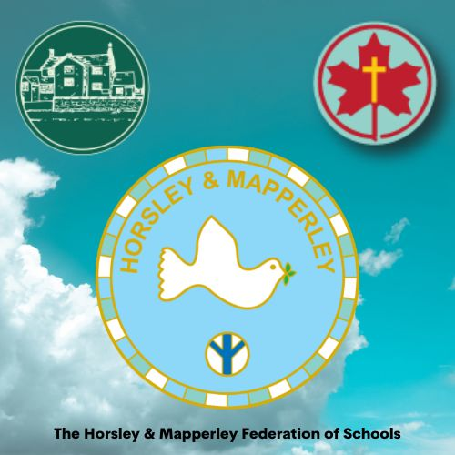  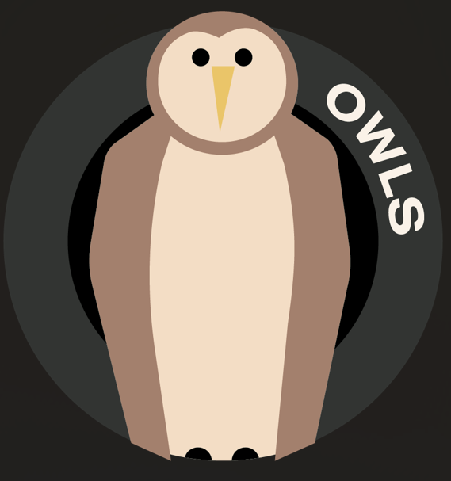  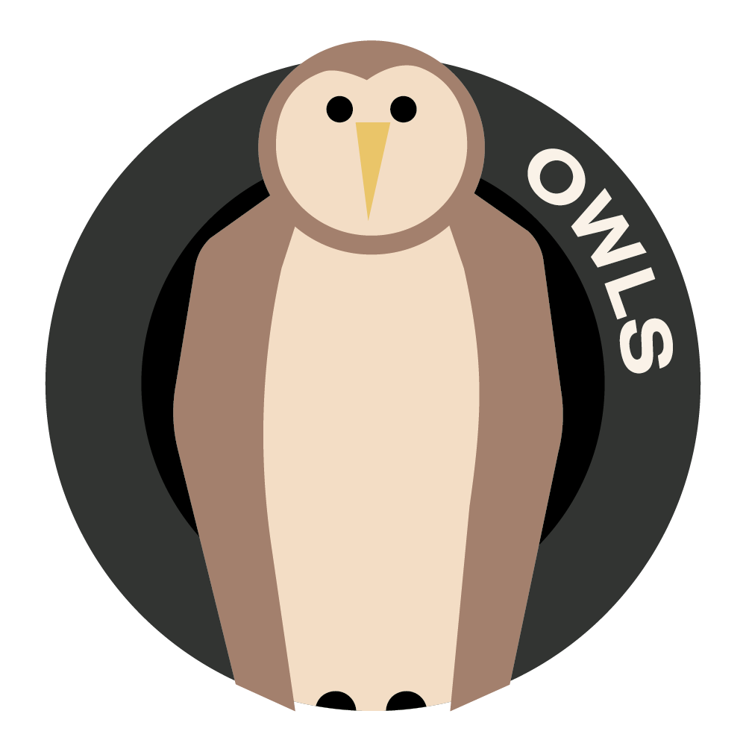
Autumn 2 2024
Dear OWLS families,

This term will be an interesting one as we explore a history focused thematic study called “Saxon King”. We will learn about Harold Godwinson, famous for being the last Anglo-Saxon king of England, ruling as a talented leader in peace and war. We will learn, through his life story, all about his achievements and what makes him such an important historical figure.
Our sticky knowledge:
Harold Godwinson was crowned in January 1066, the day after Edward the Confessor died.
Godwinson was the last Anglo-Saxon King of England.
The Battle of Hastings took place on 14 October 1066 (depicted in the Bayeux tapestry)
When Harold was defeated, the Anglo-Saxon era ended and William of Normandy became the new King of England.

In Science we have a forces topic called “May the Force be with you”. Children will be investigating different contact and non-contact forces and learning about magnets. In Maths we will continue our Multiplication and Division topic before moving on to Fractions. In English we will be reading the book The Firework Makers Daughter, analysing the structure and looking at expressive language. We then have a poetry topic. In Computing we will be learning about Internet Safety and how to research online. We will continue our Singing lessons with the Cathedral Singing Project alongside learning about Pulse and Metre. In French we are learning to order food and drink. In RE, children will be learning about Incarnation and the New Testament and will be discussing why Christians believe Jesus was the Messiah. In PSHE, children will be learning about 'Being Me'. They will have chance to discuss their likes, dislikes, hobbies, responsibilities and their role in the community, alongside listening to and respecting the views of others. We plan to get creative too throughout the term, especially leading up to Christmas!

General information - Swimming on Thursdays and PE on Fridays.

Homework expectations - Regular reading – 5 times per week please. Weekly CGP Reading Comprehension pages. Spelling – please see the attached Y3/4 and Y5/6 Spellings which we learn and assess throughout the academic year. Your child should know which words we are currently learning. Maths – Mathletics, TT Rockstars
ALSO - Purple Mash offers a range of activities, games and computing skills. It also has a wide range fiction and some non-fiction texts in Serial Mash. Many have online reading comprehension tasks.

Best wishes as we enjoy this Christmas term.
Mrs Julia Bell and Mrs Joanne Whiteley

