HORSLEY C OF E PRIMARY SCHOOL
OWLS AUTUMN 2024

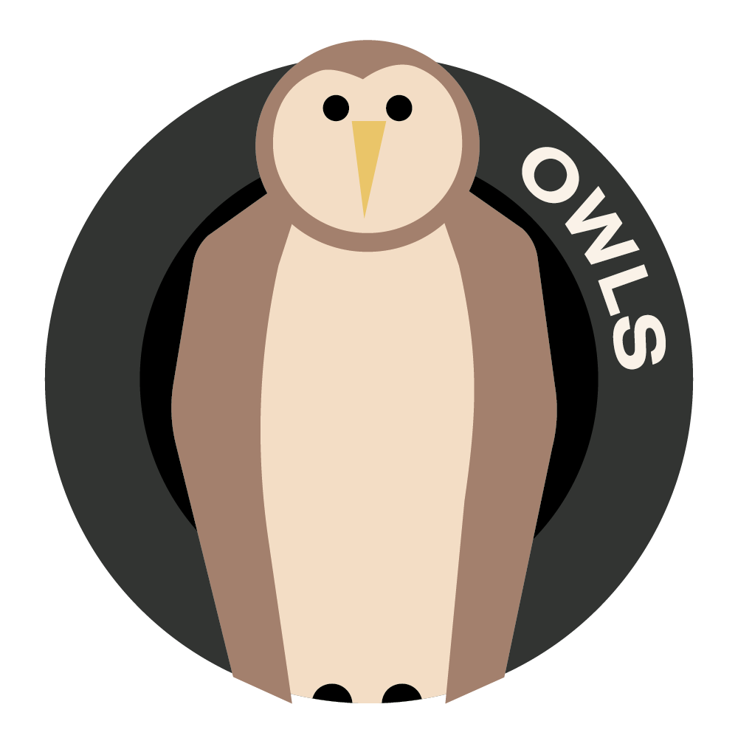

Theme Overview - ‘A World of Bright Ideas’ is a thematic unit which focuses on the creative process of invention and design. We will look at improvement inventions over time, before moving on to learning about more current issues such as patenting and copyright.
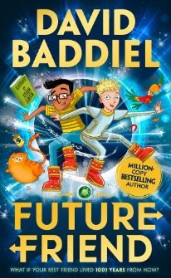
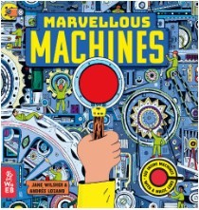
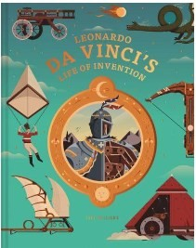
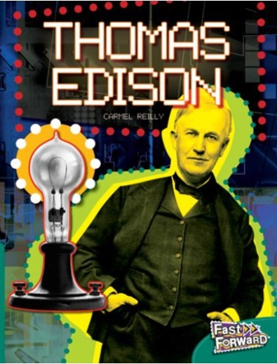
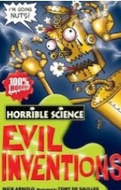
Innovation and Invention
Innovation is the process of translating an idea or invention into a product or service that creates value and is often something that customers will pay for. Here are some important inventions and their inventors:
The Lightbulb—Thomas Edison 187 The Television—John Logie Baird 1925
The Telephone—Alexander Graham Bell 1876 The Train—James Watt 1804
The Printing Press—Johannes Gutenburg 1440 The First Vaccine—Edward Jenner 1796
Can you think of any more important inventions that have improved our lives?
Recommended Reading…

What we should know
What is Copyright? Copyright is one of the ways that a person can own something they have created. This means
that they can make money from their work and make it clear to everyone that they have created it. If someone holds
the copyright for a piece of work, other are not allowed to copy it or use it without their permission. If they do, this
known as plagiarism.
What is a Trade Mark? Trade marks protect a brand name and can e words, a logo or both. When a trade mark is registered, the owner can use the symbol next to is. If people register their trademark, they can stop other people using it without their permission.
What is a Patent? A patent for an invention is granted by government to the inventor, giving them the right to stop others, for a limited period, from making, using or selling the invention without their permission. When patent protection is granted and the invention becomes the property of the inventor, it can be sold, rented or hired out by them. VOCABULARY
brand: a mark to show ownership, maker or quality commercial: about buying and selling goods and services
copyright: a law that gives the owner of a work the right to say how other people can use it
innovation: a new idea, method or device invention: something that has never been made before
logo: a recognisable and distinctive picture, name or symbol to identify a product or organisation
patent: a document that gives an inventor the right to stop other people making or using their inventions
plagiarism: using someone else’s words or ideas and passing them off as your own

Concept Flow
To understand the meaning of the term ‘copyright’ and learn about how it is important
To know about and understand what a patent is To know and understand what a trademark is
To learn about important inventions from the past

English
Spelling: Rules are taught through a range of class activities. The usage of these words are monitored in the children’s own writing. The remaining Y3/4 Statutory spellings are also covered and assessed regularly and for the Year 5s, we will begin to learn the Year 5/6 Statutory spellings. See attached.
Reading:
Wonder by RJ Palacio. Reading and answering questions about the text. Consider themes from the novel. Understand different character perspectives.
Homework – read 5 times a week at home and record this in the reading diary. Reading comprehension homework is usually set weekly.
Writing: Increase the legibility and quality of handwriting using a cursive joined style.
Compose sentences orally, progressively building a varied and rich vocabulary and an increasing range of sentence structures, extending the range of sentences by using a wider range of conjunctions.
Use adverbs and prepositions to express time and cause, using fronted adverbials
Maths: Place Value, Addition and Subtraction
Homework tasks set weekly on Mathletics and progress on TTRockstars is monitored.
Science: (3 weeks Forces, 3 weeks Electricity)
To know that unsupported objects fall towards Earth because of the force of gravity.
To identify the effects of air resistance, water resistance and friction.
To recognize that some mechanisms including levers, pulleys and gears allow a smaller force to have a greater effect.
Construct a simple series electrical circuit, identifying and naming its basic parts, including cells, wires, bulbs, switches and buzzers
Recognise some common conductors and insulators, and associate metals with being good conductors. Setting up simple practical enquiries, comparative and fair tests.
Art/DT: Investigate how the work of individuals in design and technology has helped to shape the world Communicate design ideas in different ways e.g. discussion, annotated sketches, cross-sectional and exploded diagrams, prototypes, pattern pieces and computer-aided design

Computing: Coding Design, write and debug programs that accomplish specific goals, including controlling or simulating physical systems.

Music: Analyse and compare musical features and structures using appropriate musical vocabulary
Listen carefully, demonstrating musical understanding and increasing aural memory

French: Holidays
R.E: What does it mean to be a Muslim in Britian today?
PSHE: Being Responsible
P.E: Athletics

Please talk to your children about the information on this sheet. The more children discuss their learning the more likely they are to embed the learning to their memory. If you have any questions please do not hesitate to contact your child’s class teacher by emailing the school office.

