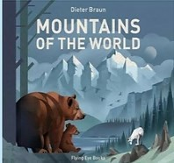
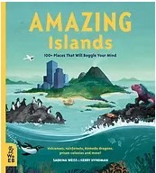
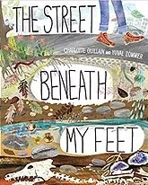
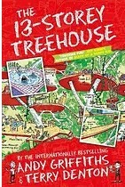
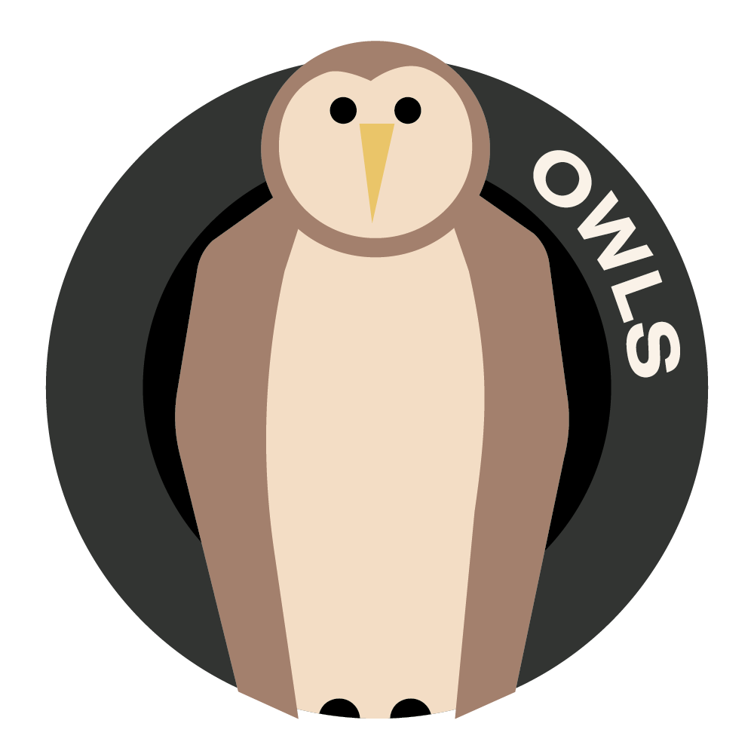
Horsley C of E Primary School

OWLS SPRING 2 2024
Theme Overview “Out and about” is a thematic unit with a key focus on geography. We will be naming and locating counties and cities of the United Kingdom, geographical regions and their identifying human and physical characteristics, using the eight points of a compass, four-figure grid references, symbols and keys; using fieldwork to observe, measure and record the human and physical features in the local area and developing an understanding of why the place our school is located is like it is.

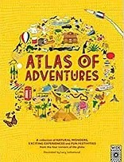
Recommended Reading…

Human or Physical?

What we should know…
Across the UK, there are many different geographical features. Most of these features can be classified as physical or human. Physical geographical features are things like rivers, mountains, lakes and valleys. They have been formed naturally over time, either by weather or by other physical features, such as glaciers forming valleys. Human geographical features are features that have been created by humans and how humans have interacted with the landscape. Humans have affected the landscape by creating settlements and adapting where they live to grow food and farm animals.
How do I get there?
Maps have been vitally important to humans for thousands of years. A map allows us to travel to unknown places and helps us to understand the land we are travelling through. Navigation starts with the four main compass points of North, South, East and West. We can then expand these by adding four more compass points:- North East, North West, South East and South West, providing greater accuracy for directions. Ordnance Survey maps were developed in the 18th Century to map out all the physical and human geographical features of the Britain. They use a standard set of symbols so anyone can point out a church, mountain or hospital in an unknown area. Map reading is still an important skill, as we cannot always rely on a GPS signal!

Knowledge and Understanding

To name and locate counties and cities of the United Kingdom, geographical regions and their identifying human and physical characteristics, key topographical features (including hills, mountains, coasts, rivers), and understand how some of these aspects have changed over time
To know and use the eight points of a compass, four- figure grid references, symbols and key (including the use of Ordnance Survey maps) to build their knowledge of the United Kingdom and the wider world

To recognise how and why places are similar to and different from other places in the same country and elsewhere in the world
To use fieldwork to observe, measure and record human and physical features in the local area using a
range of methods, including sketch maps, plans and graphs, and digital technologies

Geography: Seasons around the World - Spring in Russia
To know where Russia is located on a map
To know some of Russia’s major cities
To know what spring is like in Russia
To know what a dacha is and understand its connection with springtime

English
Spelling: Rules are taught through a range of class activities. The usage of these words are monitored in the children’s own writing. The Y3/4 Statutory are also covered and assessed regularly. See attached.
Use the first two or three letters of a word to check its spelling in a dictionary
Reading & Writing Author study – Roald Dahl and George’s Marvellous Medicine

Homework – read 5 times a week at home and record this in the reading diary. Reading comprehension homework is usually set weekly.

Maths: Fractions / Money
Homework tasks set weekly on Mathletics and progress on TTRockstrs is monitored.
Art: Sketching in the style of Quentin Blake
Computing: Touch typing / Databases
Music: Recorders with the notes B, A and G, Cathedral Singing Project
French: Food
R.E: Understanding Christianity, Salvation and The Easter Story
PSHE: Money Matters – learning about the history, importance and value of money
P.E: Invasion games and Athletics

Key Vocabulary to discuss with your child
compass: an instrument for showing direction, with a moving magnetic needle that points north
fieldwork: research, exploration, practical work or observation conducted in the natural environment rather than the laboratory or classroom
GPS: abbreviation of "Global Positioning System," a public satellite navigation system designed and controlled by the U.S. Department of Defence that provides an accurate global time reference and is used to determine a precise location on Earth
grid Reference: a map reference indicating a location in terms of a series of vertical and horizontal grid lines identified by numbers or letters l
human geography: looks at the impact and behaviour of people and how they relate to the physical world. Industrialisation: to bring industry into an area, creating places that rely on the production of goods in factories
physical geography: the branch of geography dealing with natural features
settlement: a place where people have recently settled
survey: to measure the shape, area, and elevation with special instruments so as to construct a map, plan, or description
symbol: an object or picture that represents something else.
topography: the shape of the earth's surface across an area or region The topography of an area includes the size and location of hills and dips in the landscape.

