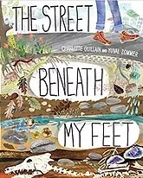
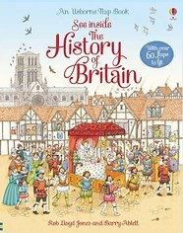
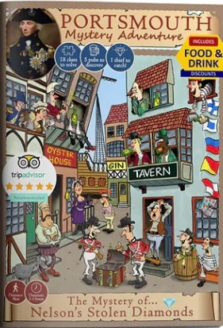

 Horsley C of E Primary School
Recommended Reading…
Theme Overview
“Time Team” is a local area research project. It involves the pupils identifying and choosing a famous person from the past who lived in their area. They will then focus on five key landmarks in Waterlooville and the surrounding area undertaking research to find out important information about each one. Once the research has been completed, the pupils will be asked to put together their very own walking tour of their town.

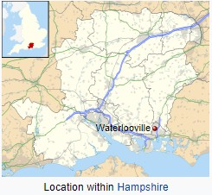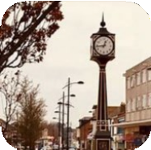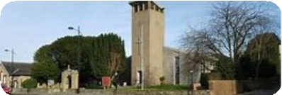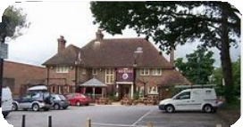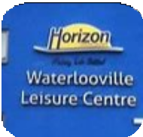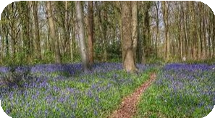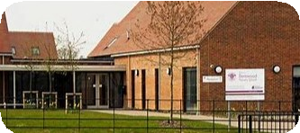
Can you name and locate these Landmarks in Waterlooville?
What we should know….
Where in the world?
Waterlooville is a market town in the Borough of Havant in Hampshire, England, approximately 6 miles (9.7 km) north northeast of Portsmouth. It is the largest town in the borough.
The town has a population of about 64,350 and is surrounded by:
Purbrook, Blendworth, Cowplain, Lovedean, Clanfield, C atherington, Crookhorn, Denmead, Hambledon, Hornde an and Widley.
It forms part of the South Hampshire conurbation. The town formed around the old A3 London to Portsmouth road.
Waterlooville is twinned with Maurepas, Yvelines in France and Henstedt-Ulzburg in Germany.

Key Vocabulary you should discuss with your child
Compass: an instrument for showing direction, with a moving magnetic needle that points north
Fieldwork: research, exploration, practical work or observation conducted in the natural environment rather than the laboratory or classroom
GPS: abbreviation of "Global Positioning System," a public satellite navigation system designed and controlled by the U.S. Department of Defence that provides an accurate global time reference and is used to determine a precise location on Earth
Grid Reference: a map reference indicating a location in terms of a series of vertical and horizontal grid lines
identified by numbers or letters
Human Geography: looks at the impact and behaviour of people and how they relate to the physical world.
Landmark: an object or feature of a landscape or town that is easily seen and recognized from a distance, especially one that enables someone to establish their location
Physical Geography: the branch of geography dealing with natural features
Resource: goods brought into another country for sale there
Settlement: natural or man-made thing that is available for a particular use a place where people live and establish a community
Survey: to measure the shape, area, and elevation with special instruments so as to construct a map, plan, or description Tourism: people travelling to and staying in places outside their usual environment
Symbol: an object or picture that represents something else.
Transportation: the movement of goods and persons from place to place
Topography: the shape of the earth's surface across an area or region The topography of an area includes the size and location of hills and dips in the land.

Concept Flow
To identify and research a famous historical figure who lived in your local area To locate and name five key landmarks in the local area using maps and plans
To learn about the five key landmarks, using a variety of sources and asking relevant questions, discover- ing how they have changed over time
To use their recent learning to plan a tour of the area for their famous visitor from the past, explaining how it has changed over time
To know how to apply their knowledge when giving a guided tour of the local area

Please talk to your children about the information on this sheet. The more children discuss their learning the more likely they are to embed the learning to their memory. If you have any questions please don’t hesitate to contact your child’s class teacher.

