


In Year 1, our writing must include:

 | CL |  | I  Tim | 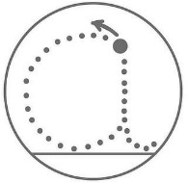
Finger spaces | Capital letters to start  sentences | Full stops | Capitals for names and I | Letters formed correctly


EVERYDAY WRITING TOOLKIT
In Year 1, our writing must include:

 | CL |  | I  Tim
Finger spaces | Capital letters to start  sentences | Full stops | Capitals for names and I | Letters formed correctly





In Year 2, our writing must include:

 | CL |  | I  Tim | 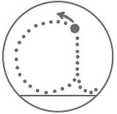 | ? !
Finger spaces | Capital letters to start  sentences | Full stops | Capitals for names and I | Letters formed  correctly | Question marks and exclamation  marks correct

EVERYDAY WRITING TOOLKIT 



In Year 2, our writing must include:

 | CL |  | I  Tim |  | ? !
Finger spaces | Capital letters to start  sentences | Full stops | Capitals for names and I | Letters formed  correctly | Question marks and exclamation  marks correct



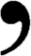


In Year 3, our writing must include:

CL |  | Capital letters and full stops
I Tim |  | Capital letter for I and names
? ! |  | Question marks and exclamation marks correct
don’t |  | Apostrophes for contractions
 | past | Correct tense throughout:
 | present | Correct tense throughout:
 | future | Correct tense throughout:
 |  | Some sentences linked with conjunctions





In Year 4, our writing must include:

CL |  | Capital letters and full stops
I Tim |  | Capital letter for I and names
? ! , |  | Question marks, exclamation marks and commas in list correct
 | don’t  Tim’s | Apostrophes for contraction and possession
 | past | Correct tense throughout:
 | present | Correct tense throughout:
 | future | Correct tense throughout:
 |  | Sentences linked with conjunctions
 |  | Structured in paragraphs


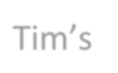



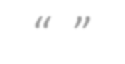
In Year 5, our writing must include:

CL  |  | Capital letters and full stops
I Tim |  | Capital letter for I and names
? ! , “ ” |  | Question marks, exclamation marks, commas (list and fronted adverbials) and inverted commas used correctly
 | don’t Tim’s | Apostrophes for contraction and possession
 |  | Correct tense and Standard English
 |  | Sentences linked with conjunctions (varying position)
 |  | Structured in paragraphs


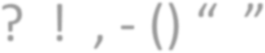

In Year 6, our writing must include:

CL |  | Capital letters and full stops
I Tim |  | Capital letter for I and names
? ! , - () “ ” |  | Question marks, exclamation marks, parenthesis and inverted commas used correctly
 | don’t Tim’s | Apostrophes for contraction and possession
 |  | Correct tense and Standard English
 |  | Sentences linked with conjunctions (varying position)
 |  | Structured in paragraphs

