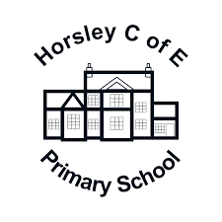

Horsley C of E Primary School

Handwriting Policy

CONTENTS:
Introduction p3
Aims p3
Progression of Teaching and Learning of Handwriting p3
Pedagogy & Resources for Teaching and Learning of Handwriting p5
SEND & Identified / Particular Weakness p8
Time Allocation for Handwriting Teaching and Practice p9
Posture and Environment p9
Pencil Grip p9
Assessment, Monitoring and Moderation p10
APPENDIX A…
APPENDIX B
APPENDIX C
Introduction:
This guidance has been written in line with the statutory and non-statutory requirements for Writing Transcription across KS1 and KS2 in the National Curriculum, the EYFS Framework and the Essential Letters and Sounds handwriting guidance for developing correct letter formation.
This policy represents a whole school approach designed to help children work towards developing a confident, efficient and legible handwriting style. It provides advice for teachers in this regard and also advice on how to support children with SEND (where writing transcription requires adaptations) and also those for whom handwriting is a recognised particular weakness (as defined in the
Department for Education’s Assessment and Reporting Arrangements for Key Stage 2 SATS 2025)
Aims:
At Horsley, we aim:
- To have a consistent approach to handwriting across the whole school to ensure high levels of written presentation
- To adopt a common approach towards handwriting by all adults when writing in children’s books on the whiteboard or on displays or resources.
- For children to progressively achieve a neat, legible style with correctly formed letters in cursive handwriting
- For children to develop good fluency and foundational transcription skills whilst writing, so that eventually they are able to transcribe with confidence, efficiency and stamina.

Progression of Handwriting at Greenway:
EYFS
In Reception, children are supported from the earliest stages of learning to write. Children are taught letter formation as part of their daily ELS Phonics programme and the formation of the numbers 0-9. Children are taught phrases (as set out by ELS) to aid retention and skill when forming each letter. Handwriting is taught daily within ELS sessions. A clear focus on posture, writing tool grip, fine motor skills and hand-eye coordination is planned for and provided within these lessons and the wider curriculum.
Year 1
In Year 1, conditions are clearly set and created for good writing: atmosphere, seating and posture, and pencil grip (Appendix B), as well as continuing to develop fine motor skills and hand-eye coordination. Children practise their letter formation daily during ELS Phonics lessons and there is a discrete weekly handwriting lesson.
Children learn how to sit for writing, how they should hold their pencil and how they should position their paper on the desk (depending on which hand children naturally /automatically hold their pencil).
The children practice correct formation of all of the lower-case and capital letters in sets based on how letters are formed (APPENDIX C) as well as the formation of the digits 0-9. Teachers model each letter with clear and consistent instructions about how to start and finish letters / digits and children practise these in a cumulative manner.
Year 2
At the start of Year 2, children revise the correct letter formations (APPENDIX B) with a focus on consistency and appropriate letter size. Attention is given to ‘lead out’ strokes and children are taught how to loop descenders - both in preparation for joining.
By the Spring term, children who are ready (that is, have mastered correct letter formation for all lowercase letters and write them with a consistent and appropriate letter size) are taught to join letters. Children are taught that some letters are best left un-joined when next to other letters (APPENDIX D).
Year 3 & 4
In Years 3 & 4, pupils are provided with practice sessions that focus on building their confidence with the diagonal and horizontal strokes associated with joining letters (as well as the ‘break letters’ that are left un- joined) in order to increase their pace and fluency. There is an emphasis on spacing letters consistently, on maintaining proportion with ascenders and descenders and increasing stamina for cursive handwriting.
Years 5 & 6
Handwriting practice continues across these year groups primarily to develop pace, consistency and stamina for writing. Children are empowered to develop their own style of joined writing from their secure base, choosing to write with a ball-point pen or pencil as appropriate to the occasion. In addition through this phase, children develop general presentation skills through a range of provided opportunities, building spatial awareness and orientation as they are exposed to an increasing range of presentational demands e.g. drawing graphs, tables, diagrams and annotations.

Handwriting Endpoints by phase
YR | Reception Pupils will have been taught to:  - Hold a pencil effectively– using the tripod grip in almost all cases.  - Begin to show accuracy and care when drawing.  - Write recognisable letters and numbers, most of which are correctly formed.
Y1 | Y1 Pupils will have been taught to:  - sit correctly at a table, holding a pencil comfortably and correctly  - form lower-case letters in the correct direction, starting and finishing in the right place  - form capital letters  - form digits 0-9  - understand which letters belong to which handwriting ‘families’ (i.e. letters that are formed in similar ways)

 | - leave spaces between words.
Y2 | Y2 Pupils will have been taught to:  - form lower-case letters of the correct size relative to one another  - start using some of the diagonal and horizontal strokes needed to join letters and understand which letters, when adjacent to one another, are best left unjoined. Most children are expected to be joining letters by the end of Year 2.  - write capital letters and digits of the correct size, orientation and relationship to one another and to lower case letters  - use spacing between words that reflects the size of the letters
Y3 & 4 | Y3 & 4 Pupils will have been taught to:  - practice using the diagonal and horizontal strokes that are needed to join letters and understand which letters, when adjacent to one another, are best left unjoined  - increase the legibility, consistency and quality of their handwriting (e.g. ensure down strokes of letters are parallel and equidistant; lines of writing are spaced sufficiently so that the ascenders and descenders of letters do not touch).
Y5 & 6 | Y5 & 6 Pupils will have been be taught to:  - write legibly, fluently and with increasing speed by:  - deciding whether or not to join specific letters  - choosing the writing implement that is best suited for a task  - Present a variety of work appropriately on the page including graphs, diagrams, annotations and table.

Pedagogy & Resources for Teaching and Learning of Handwriting
All handwriting lessons will involve clear and precise modelling by adults, plenty of practice time, appropriate differentiation and plenaries / mini-plenaries to address identified misconception and issues. Teachers should draw attention to handwriting and general presentation through the week and celebrate progress and success.
EYFS:
Teachers will follow the ELS programme of study, which incorporates Handwriting progression, using ELS resources.
Children will have age appropriate handwriting resources in Early Years. For example, chunky crayons, chalks, tri-pencils and felt-tip pens. Some children will use pencil grips and writing supports in Reception.
Year 1:
Teachers will teach Horsley’s agreed models for letter formation, teaching letters in progressive sets (APPENDIX C).

Teachers should aim to teach one set over a number of weeks with plenty of opportunity to practice including ‘air writing’ and tracing as well as independent writing, differentiating as appropriate.
Attention should be drawn to the guiding lines on the pages in their books and, through modelling, how to carefully position the strokes of each letter within / on the appropriate lines.
Some children may use pencil grips or have other supports such as wider ‘grip’ pencils, slopng writing surfaces or targeted support with an adult.
Year 2:
Teachers will teach Horsley’s agreed models for letter formation, revising letter formation in progressive sets (APPENDIX C) before moving on to teaching letter joins in progressive joining sets.
Teachers should aim to teach one set over a number of weeks with plenty of opportunity to practice including ‘air writing’ and tracing as well as independent writing, differentiating as appropriate.
Attention should be drawn to the guiding lines on the page throughout and, through modelling, how to carefully position the strokes of each letter within / on the appropriate lines.
Children should continue to be exposed to the correct language of handwriting: ascenders; descenders; lead in / lead out
Some children may use pencil grips or have other writing supports.

Year 3 & Year 4:
Teachers will revise the joining of letters in progressive sets (APPENDIX D).
Teachers should revise each of the joining sets over 2-3 weeks with plenty of opportunity to practice including tracing over as well as independent writing, differentiating as appropriate
Children who have not yet mastered correct letter formation should be provided with appropriate practice (revising the letter formation sets of APPENDIX C) and, unless there is an identified particular weakness, additional interventions should be scheduled through the week to develop fine motor skills and muscle memory for correct letter formation..
Through Year 3 and 4 children should progressively build to practice joining letters across the joining groups and by Year 4, handwriting practice should focus on teacher identified areas of weakness or
‘tricky joins’.
Teachers continue to model on the interactive whiteboard whilst providing handwritten resources for children to trace and copy in their books.
Attention should be continually drawn to ensuring children are writing consistently on the line and general neatness.
Children should continue to be exposed to the correct language of handwriting: ascenders; descenders; lead in / lead out
Once children show they can join all letters with consistency, accuracy and neatness, children can begin writing with a ball pen at the discretion of the teacher. This will typically happen during Year 4
Some children will use pencil grips and writing supports.
Year 5 & Year 6
Teachers will revise the joining of all letters and use handwriting to identify particularly needs or weaknesses that are inhibiting consistent, efficient writing flow.
Teachers should revise each of the joining sets if appropriate to do so – or else identify particular joins that need work (tricky joins). Children will be given plenty of opportunity to practice including tracing over as well as independent writing, differentiating as appropriate
Through Year 5 and 6, Teachers should provide handwritten resources for children to trace and copy in their books, using the interactive whiteboard when appropriate / necessary to highlight misconceptions or clarify expectations.
Attention should be continually drawn to ensuring children are writing consistently on the line and general neatness.
Children should continue to be exposed to the correct language of handwriting: ascenders; descenders; lead in / lead out.
Some children will use pencil grips and writing supports.
Identified / Particular Weakness in Handwriting
Some children, for a variety of reasons, have difficulty in producing legible, correctly formed and orientate handwriting. Children needing additional support should receive short bursts of handwriting practice with a Teacher or Teaching Assistant as often as possible.
Children with SEND (Special Education Needs and/or Disabilities):
Children with SEND, where physical difficulties have been identified and where it is affecting their letter formation and/or speed and fluency of writing, will be provided with the appropriate adjustments to reduce the barriers to writing.
Targets and provision may form part of their SEND ‘Individual Education Plans’ using the Graduated approach of ‘Assess, Plan, Do and Review.’
Adjustments and provision will be personalised for the child and may include:
- Use of strengthening putty and exercises for fine motor skills
- Over hand support for fine motor control
- Activities to rehearse early writing development skills such as tracing over lines and coloured shapes
- Use of sensory tools to trace and practise letters e.g.: sand tray
- Writing slopes
- Enlarged writing frames and adapted highlighted practise papers
- Specialised Pencils/pens and pencil grips
- Scribed work as required
- Personalised and group handwriting sessions
- Writing aids using IT such as an i-pad pen and laptops to type work
In Lower Key Stage 2, children with an identified particular weaknesses in handwriting should continue to access interventions to support correct letter formation.
In Upper Key Stage 2, those children who have an identified weakness or barrier to legible handwriting with correct letter formation can have access to laptops, be signposted to touch typing courses, be supported to identify when typing is the better choice and, when it is not, have adjustments in place to support with other presentational demands such as annotating, drawing and labelling diagrams and graphs etc.

Early identification of difficulties with fine motor control and writing:

Children in Foundation Stage will be provided with daily opportunities to develop their fine motor skills and emergent writing for purpose through both adult-led learning and CIP (Child initiated play).

Teachers will focus on early identification of any difficulties with fine motor control and implement the appropriate adjustments to reduce physical difficulties and barriers to writing and develop confidence in their mark making by praising their efforts, and to write by encouraging them to ‘have a go’ and not to worry about making mistakes.

Time allocated for discrete Handwriting teaching and practice:
- Children in Reception – catered exclusively through ELS with an additional / explicit handwriting lesson once a week.
- Children in Key Stage 1 – 1 x 30 or 2 x 15 minute handwriting sessions a week (in addition to ELS)
- Children in Key Stage 2 – 1 x 15 minute handwriting session a week Handwriting and general presentation expectations are reinforced daily in every lesson.
Children who find handwriting difficult will be targeted for intervention where appropriate, taking into account any SEND.

Posture and Environment
Chairs and tables in classrooms are matched to children’s age and height.
Children’s backs should be straight and resting on the floor. A right-handed child should have their book slanted to the left. For a left handed child the book should be slanted to the right. Teachers should ensure that the hand that is not holding the pencil or pen holds the paper. Children are taught how to sit correctly and how to hold the correct posture as part of their handwriting lessons.
Left-handed children should sit on the left side of right-handed children so that their elbows don’t bump.
Whiteboards and pens may be used for practice during phonics sessions.

Pencil Grip
If children are to develop a fluid and rapid writing style then they must learn how to hold a pencil with a grip that is relaxed but allows for efficient pencil control.
Children should be taught to adopt a tripod grip and to hold the pencil lightly between the thumb and forefinger about 2cm from the point. The middle finger provides a rest /cushion for the pencil.
Left-handed children should be aware that when making joining strokes the letters are pushed, not pulled. Encourage Left-handed children to hold their pencil far enough away from the point to allow them to read what they are writing.
Care should be taken that children do not grip the pencil too tightly as this produces tension in the arm and shoulder.

Assessment, Monitoring and Moderation
Children in the EYFS are assessed on an ongoing basis through observation; handwriting informs part of this. Within Key Stage 1 and Key Stage 2, Handwriting is also assessed as part of children’s writing assessments using the assessment criteria for given year groups.

APPENDIX A

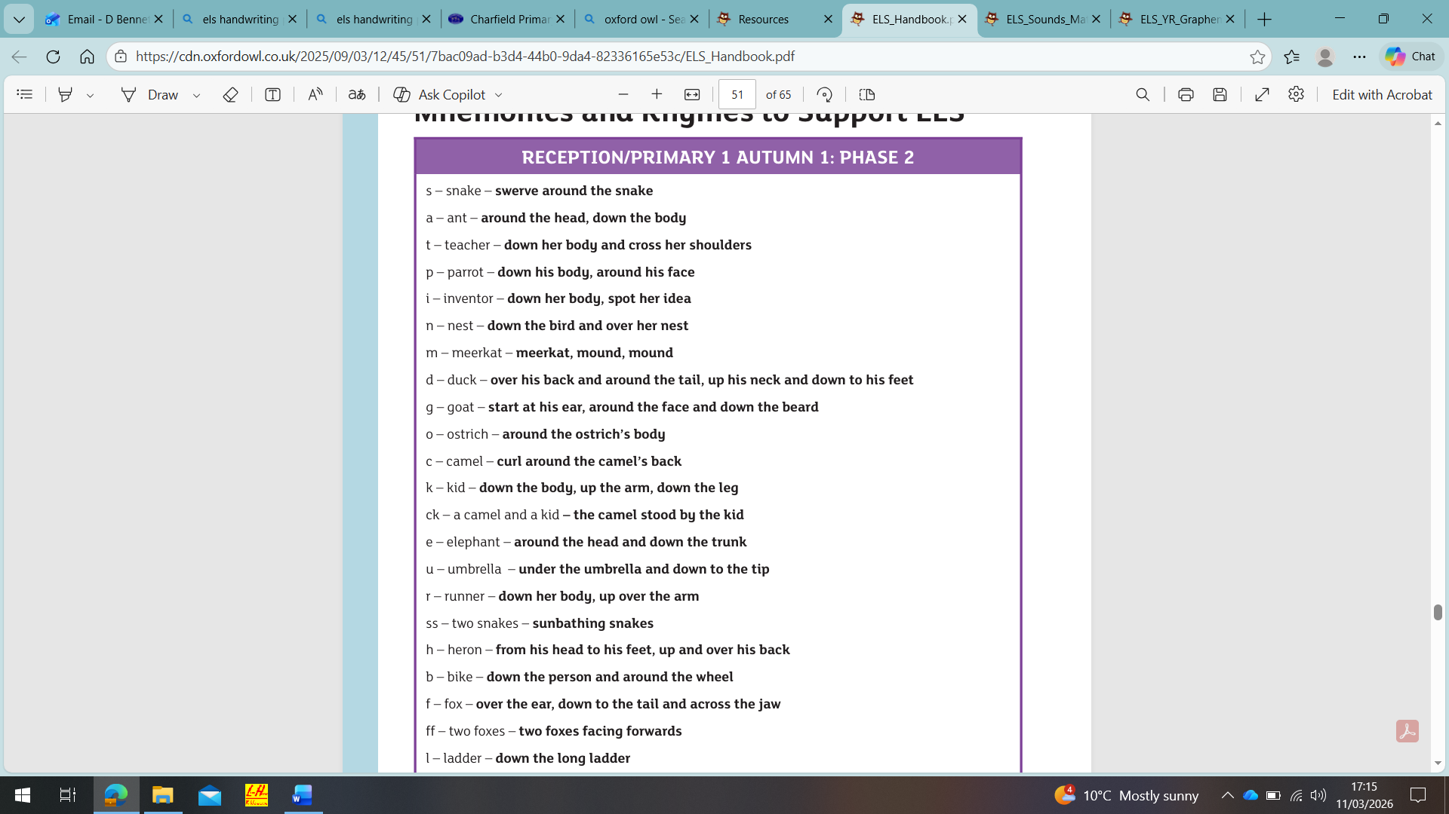

APPENDIX B
Children in Year 1 should have the image (below 1) stuck inside their handwriting book as a reminder ‘flap’. Teachers can refer to this at the start of each lesson.
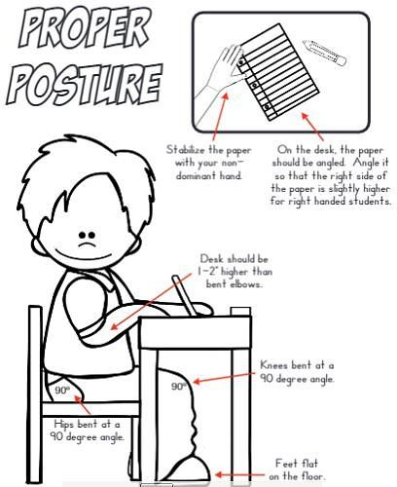
Teachers might also want to use the Handwriting Rhyme at (below 2) the start of each lesson



