 |  |  | 
   | DERBYSHIRE INCLUSION  School Inclusion Strategy Summary
School name  Horsley C of E Primary School | Academic year  2026-2027 | Date published  ____________________ | Review date  ____________________ | Authorised by  ____________________
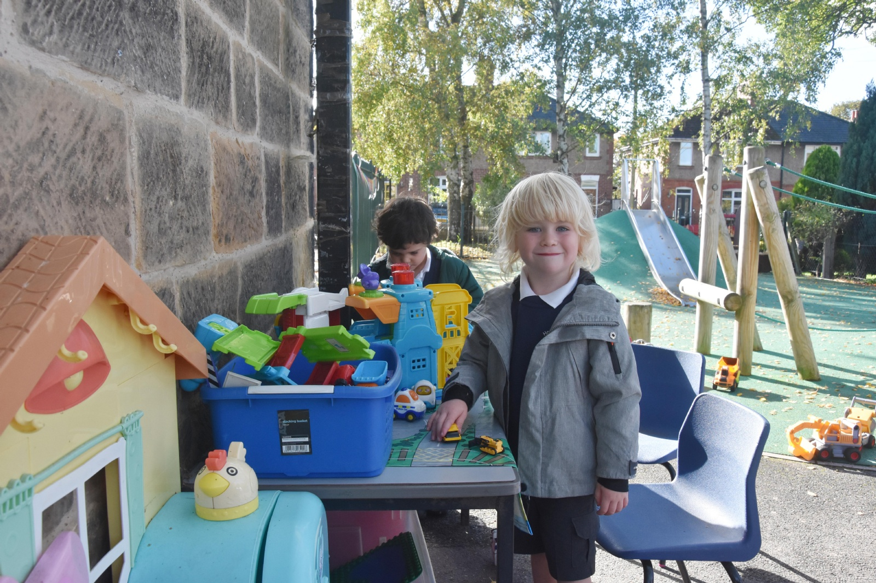 |  | Our commitment to inclusion  At Horsley C of E Primary School, every child belongs, participates, and achieves. We identify and remove barriers to learning, participation and wellbeing through high-quality teaching, reasonable adjustments and strong partnership with pupils, families, and professionals. Our inclusive practice is supported through our core school budget, including the notional SEN budget, and where applicable the Inclusive Mainstream Fund. Our approach is informed by the Derbyshire Inclusion Framework and our Whole School Provision Maps, which help us identify strengths, barriers, priorities and the provision needed to support all learners. We review these regularly so that provision remains responsive to the needs of our school community.

Our Inclusion Principles
1. Belonging  A Safe and Respectful Culture  Every pupil feels safe, valued, and included. | 2. Responsibility  Ambitious Leadership and Governance  Inclusion is everyone’s responsibility. | 3. Flexibility  Inclusive Environments  We adapt teaching, environment, and approach. | 4. Identification  Evidence-Based Support  Needs and barriers are identified early.
5. Provision  High Quality Adaptive Teaching  Support is matched to need and reviewed. | 6. Opportunities  Enriching Provision  All pupils can access wider school life. | 7. Championing  Celebrating Diversity and Achievement  We celebrate diversity and achievement. | 8. Co-production  Strong Partnerships  Children and families shape decisions.
OUR PRIORITIES AND IMPACT
Key barriers we are addressing.
Barrier 1  Describe the barrier, trend or theme:  Many of our Neurodiverse pupils face challenges with attention, communication and sensory processing within the classroom. These barriers often disrupt learning and affect the overall success of the child. | Barrier 2  Describe the barrier, trend or theme:  To have inclusive classrooms fostering a supportive learning environment that enhances empathy, reduces social anxiety, and encourages positive social interactions among all students, so that ND students do not feel alone. | Barrier 3  Describe the barrier, trend or theme:  A selection of pupils in the school have poor attendance. Often parents are unsure how they can help their child with issues such as school refusal, attachment issues, extreme anxiety or school phobia.
Our three inclusion priorities this year
Priority 1  Focus: To support the high needs of the Neurodiverse pupils within the school  Barrier addressed: To develop positive learning strategies and behaviours of Neurodiverse pupils  What we will do:  Staff supported by the ISAT team to develop ND awareness and Executive Functioning and how to support the development of Executive Functioning skills within the classroom.  Children will be supported to use strategies to help them with Executive Functioning skills so that they can work with increasing independence and have their needs met.  ISAT observations, work with teacher to understand what strategies could be implemented which don't require additional adults, awareness of ND friendly teaching and learning approach.  Activity type: Universal  Funding: IMF  Success will look like:  To support the high needs of neurodiverse pupils within the school, there will be an inclusive environment that accommodates for their diverse learning styles and sensory needs. This may involve:  Adapting classrooms and resources – Tailoring classroom environments to meet the specific needs of neurodiverse learners, such as using preferred colours, fonts or visual aids.  Emphasizing Flexibility – Implementing flexible approaches that recognize the unique ways in which neurodiverse pupils respond to their environment, such as allowing movement and sensory input.  Fostering Positive Behaviour – Utilising strategies like Zones of Regulation, to help pupils manage their emotions and build better relationships. | Priority 2  Focus: Develop ND awareness within the school community  Barrier addressed: Pupils in the school will develop their awareness of Neurodiversity and how people are all different.  What we will do: ISAT Team will work in classrooms to help the pupils understand that people's brains are different and develop ways to help and support each other (ND friendly/affirming)  Many neurodivergent children have distinct strengths:  - Autistic pupils may show exceptional attention to detail, pattern recognition, or deep knowledge in a particular area.  - ADHD pupils often thrive in creative, high-energy, problem-solving tasks.  - Dyslexic pupils may excel in reasoning, verbal communication, and big-picture thinking.  Activity type: Universal  Funding: IMF  Success will look like:  Success for pupils developing awareness of neurodiversity would mean they not only understand differences but also value them in everyday interactions. It’s about moving beyond knowledge into empathy, respect, and inclusion.  Here’s what that could look like in practice:  - Knowledge & Understanding  Pupils can explain what neurodiversity means, recognise that brains work in different ways, and identify examples such as autism, ADHD, dyslexia, and dyspraxia without stereotypes.  - Empathy & Respect  They show kindness and patience towards peers with different communication styles, learning needs, or sensory preferences, and avoid making assumptions about abilities.  - Inclusive Behaviour  In group work, play, and discussions, they adapt their approach so everyone can participate—e.g., giving extra time, using clear language, or offering alternative ways to contribute.  - Positive Advocacy  Pupils challenge unkind behaviour, speak up against exclusion, and actively promote fairness and acceptance in their school community.  - Celebration of Strengths  They recognise that neurodivergent people bring unique talents, perspectives, and problem-solving approaches, and they celebrate these as valuable to the group.  If this vision is achieved, you’d see a school culture where differences are not just tolerated but embraced—where pupils instinctively create spaces where everyone feels they belong. | Priority 3  Focus: To increase the attendance of pupils by holding a series of SEND coffee mornings for parents.  Barrier addressed: Pupils who have low attendance at school will follow the schools Attendance Policy and Graduated Response Document, with the aim to increase their time in school and reduce absence. Parents will be able to ask questions, further develop their relationship with the school and learn how school supports SEND/vulnerable pupils.  What we will do:  Tailor interventions and support services to meet the specific needs of these students and their families, so that regular attendance in school improves and cases of their absences lessen.  ISAT will be able to deliver LA information relating to SEND and ‘present’ information around the areas parents have requested so they are upskilled and empowered through increased knowledge and awareness.  Activity type: Targeted  Funding: IMF  Success will look like:  Success in improving pupil attendance isn’t just about hitting a percentage target — it’s about creating a culture where being in school is valued, supported, and celebrated. In practice we hope to develop:  - Consistently High Attendance Rates  - Overall attendance is at or above national benchmarks (often 95%+).  - Persistent absence (below 90%) is significantly reduced.  - Positive Pupil Engagement  - Pupils arrive on time, ready to learn, and participate actively in lessons.  - There’s a noticeable improvement in classroom energy and focus.  - Strong Relationships with Families  - Parents and carers understand the importance of attendance and feel supported, not judged.  - Communication about attendance is proactive, clear, and solution-focused.  - Parents feel that they have been upskilled in areas of SEND to help them to respond to any needs that may arise with their child.  - Early Intervention Systems Working Well  - Absence patterns are spotted quickly, and support is offered before issues escalate.  - Staff, pastoral teams, and external agencies work together seamlessly.  - A Welcoming, Inclusive School Environment  - Pupils feel safe, valued, and connected to their school community.  - Incentives and recognition for good attendance are meaningful and fair.  - Parents feel comfortable attending coffee mornings and will be able to ask questions, further develop their relationship with the school and learn how school supports SEND/vulnerable pupils.  - Sustainable Improvement  - Attendance gains are maintained over time, not just during short-term campaigns.  - Strategies are embedded into the school’s culture and policies.

How we know we are making a difference
✓  Attendance & engagement  - Overall attendance is at or above national benchmarks (often 95%+).  - Persistent absence (below 90%) is significantly reduced. | ◆  Participation  - After school clubs/ sporting events will be attended by more pupils, including those who are neurodiverse. | ▲  Progress & achievement  - Neurodiverse pupils will be working at Age-Related Expectations. Those with EHCP’s will be working towards their Individulised targets/objectives for their Key Stage.
♥  Wellbeing  - Pupils will be less anxious on arrival at school in a morning and be able to use strategies to help cope with their feelings. Clear, established routines will help them to feel more secure in their daily life. | ✦  Pupil voice  - School council meetings, taking into account information from “Class Councils.”  - English and Maths “Pupil voice” questionnaires.  - Wellbeing pupil voice questionnaires | ✉  Parent/carer feedback  - Meeting with parents.  - Parents questionnaires.
Review of last year’s impact
From year two onwards, briefly summarise what changed as a result of last year’s Inclusion Strategy, including impact on attendance, engagement, participation, wellbeing, sense of belonging and progress for pupils with additional needs and SEND.
Summary of impact: Not Applicable this year.
________________________________________________________________________________
________________________________________________________________________________
________________________________________________________________________________
Working together
This strategy should be shaped by pupils, parents and carers, staff, governors, and partner agencies. Schools should use feedback, school data and review activities to shape priorities and strengthen provision.
How we have listened and responded:
We are in the process of acquiring the views of the children in the school, through our school council. Parents are being consulted via a questionnaire. The Governing body will have the opportunity to discuss the strategy at their meetings. Once all stakeholder views have been gathered, we will update this Inclusion Strategy plan.
Further information
☐ SEND Information Report
☐ SEND Policy
☐ Accessibility Plan
☐ Whole School Provision Maps
☐ Inclusion Framework
☐ Derbyshire Local Offer

